A Project Report on

“Analyzing the Impact of Climate Change on Agricultural
Productivity Using Statistical Methods”



UNIVERSITY POST GRADUATE COLLEGE (OU)SECUNDERABAD
(A Constituent College of Osmania University)
DEPARTMENT OF DATA SCIENCE
M.SC.DATA SCIENCE II YEAR [2024-2026]

Submitted by

BODANAM MANASA 101024559011

Under the Guidance Of
Mr. Dr. B. Ranganatha Rao
(Assistant Professor, Dept of Computer Science)


Estd:1947
UNIVERSITY POST GRADUATE COLLEGE, OU
SECUNDERABAD
( A Constituent College of Osmania University)
S.P. Road, Secunderabad - 500 003. Telangana State, INDIA
Tel:(Off) : 040-27902169, website . www: upgcs.ac.in e-mail : oupgcs@gmail.com

CERTIFICATE

This is to certify that the Capstone project work report entitled “Analyzing the Impact of
Climate Change on Agricultural Productivity Using Statistical Methods” submitted by
B.Manasa bearing Roll Number:1010-24-559-011respectively, studying in MSc.Data Science IV Semester, to the Department of Data Science, University Post Graduate College OU Secunderabad, Hyderabad, is record of the original project work carried out by me under my guidance and supervision during the IV semester of MSc. Data Science program. The work embodied in this project work has not been submitted fully or in part anywhere else

Guide Head
Dr. B. Ranganatha Dr. B. Suresh
Assistant Professor Assistant Professor

Department of Data Science

Name and Signature of External Examiner

DECLARATION

I, Bodanam Manasa (Roll No: 1010-2455-9011) hereby declare that the technical report entitled “Analyzing the Impact of Climate Change on Agricultural Productivity Using Statistical Methods” is done by me, submitted in partial fulfilment of the requirements for the award of the degree of MSc. Data Science in the year 2025-2026.

Date:
Place: SECUNDERABAD
BODANAM MANASA (1010-2455-9011)

ACKNOWLEDGEMENT
I express my sincere gratitude to Dr. S. KAVITHA DEVI principal, OUPGCS, for providing and excellent academic environment in the college. I express my gratitude to Dr. B. Suresh, Assistant Professor Head of the Department, for providing with both time and amenities to make this project a success within the time schedule.
I take a unique privilege to express my thanks to Dr. B. Ranganatha Rao, Assistant Professor internal guide, for his valuable guidance and encouragement given to me throughout this
project.
It has been a highly encouraging and knowledge gaining experience which has been a source of inspiration throughout the project and has helped me with all my problems.
During this work I have gained both practical as well as theoretical knowledge of great significance. Iam greatly thankful to all faculty members of PG College who have helped me through this work. Iam greatly obliged to Dr. B. Ranganatha Rao, Assistant Professor for his suggestions and help apart from that Iam highly obliged to my internal guide
Dr. B. Ranganatha Rao, Assistant Professor
I extend my thanks to all the people, who have helped me a lot directly or indirectly in the completion of academic projects.
Best regard

ABSTRACT

Climate change is a major challenge affecting agricultural productivity and global food security. Crop productivity and agricultural sustainability are greatly impacted by variations in climate variables as temperature, precipitation, and carbon dioxide (CO₂) emissions. Using a large agricultural dataset that includes data on climate, crop production, geography, soil health, irrigation, and adaption strategies, this study statistically examines how climate change affects agricultural productivity. Pearson Correlation Analysis and correlation heatmaps were utilized to explore correlations between climate variables and agricultural yield. Multiple Linear
Regression investigated the influence of climate conditions on agricultural output, while OneWay ANOVA compared crop yield among countries, regions, crop kinds, and adaption measures.
The Kruskal–Wallis Test evaluated the impact of adaptation tactics on crop output, and trend analysis was used to look at changes in agricultural productivity over time. The findings demonstrated that different climate factors have different degrees of impact on agricultural output, with average temperature showing the largest positive correlation with crop yield. Variations in agricultural productivity are caused by a combination of climate variables, according to regression analysis. There were no statistically significant variations in crop output between the category groups examined, according to ANOVA and the Kruskal-Wallis Test. Over the course of the study, trend analysis revealed rather steady crop output with just slight variations. All things considered, the study offers insightful statistical information about the relationships between climate change and agriculture and helps researchers, policymakers, and farmers create practical plans for sustainable agricultural productivity in the face of shifting climate conditions.

TABLE OF COMMON ABBREVATIONS
Abbreviation | Full Form
ANOVA | Analysis of Variance
CO₂ | Carbon Dioxide
F | F-Statistic
GIS | Geographic Information System
H | Kruskal–Wallis H Statistic
H₀ | Null Hypothesis
H₁ | Alternative Hypothesis
IPCC | Intergovernmental Panel on Climate Change
JN | Jupyter Notebook
MAE | Mean Absolute Error
MLR | Multiple Linear Regression
MT | Metric Ton
MT/HA | Metric Tons per Hectare
OLS | Ordinary Least Squares
P-value | Probability Value
R | Pearson Correlation Coefficient
R² | Coefficient of Determination
RMSE | Root Mean Square Error
SciPy | Scientific Python Library
Seaborn | Statistical Data Visualization Library
SKLearn | Scikit-learn
η² | Eta Squared (Effect Size)
TABLE OF CONTENT

TOPIC PAGE NO

Chapter 1: INTRODUCTION ----------------------- 1-13
1.1 Introduction
1.2 Motivation to the Topic
1.3 Significance and Need of the Study
1.4 Problem Statement
1.5 Objectives of the Study 1.6
Chapter-wise Summary
Chapter 2: REVIEW OF THE LITERATURE ------------------------14-20
2.1 Introduction
2.2 Review of Existing Research Works
2.3 Comparative Analysis of Reviewed Studies
2.4 Summary
Chapter 3: DATA DOMAIN -----------------------------------21-28
3.1 Introduction
3.2 Domain Overview
3.3 Sample dataset description
3.4 Dataset Characteristics
3.4.1. Attributes in dataset
3.5 Feature Categorization
3.6 Sample Dataset Records
3.7 Dataset Relevance to Research Objectives
3.8 Summary
Chapter 4: STATISTICAL TOOLS AND SOFTWARE’S USED ----------------29-38
4.1. Introduction
4.2. Software used
4.2.1. Python libraries used
4.3. Basic Statistical tools used
4.3.1. Advanced Statistical methods used
4.3.2. Model Evaluation Techniques
4.4. Summary
Chapter 5: DATA VISUALIZATIONS ------------------------------------------39-47
5.1. Introduction
5.2. Visualization Tools used
5.2.1.Correlation Heatmap Visualization
5.2.2.Regression Analysis Visualization
5.2.3.BoxPlot Visualization for ANOVA
5.2.4.Trend Analysis Visualization
5.2.5.Boxplot for Adaption Strategies
5.3 Summary
Chapter 6: EXPLORATORY DATA ANALYSIS-------------------------------------48-58
6.1. Introduction
6.2. Dataset Overview
6.2.1. Dataset Description
6.2.2. Dataset Information
6.3. Descriptive Statistics
6.3.1. Statistical Summary
6.3.2. Boxplot Analysis
6.3.3. Pair Plot Analysis
6.3.4.Correlation Matrix
6.4. Summary
Chapter 7: MODEL BUILDING/ADVANCED DATA ANALYSIS TECHNIQUES--59-83
7.1. Introduction
7.2. Pearson Correlation Analysis
7.3. Multiple Linear Regression
7.4. One-Way ANOVA Analysis
7.5. Trend Analysis
7.6. Kruskal Wallies Test
7.7. Summary

Chapter 8: CONCLUSIONS &FUTURE SCOPE------------------------------84-86
8.1. Conclusion
8.2. Future Scope
Chapter 9: APPENDIX ---------------------------------------------87-96
9.1. Program Code for Implementation
Chapter10: BIBLIOGRAPHY ---------------------------------------------97-99
Chapter 11: PLAGIARISM REPORT -------------------------------------------100

1.INTRODUCTION

1.1. Introduction
One of the biggest worldwide issues influencing food security and agricultural productivity is climate change. Crop growth and agricultural sustainability have been significantly impacted by climate change, which includes rising temperatures, shifting precipitation patterns, and rising carbon dioxide (CO₂) emissions. Understanding how climate factors affect crop yield has become crucial for farmers, academics, and policymakers because agriculture is heavily reliant on environmental circumstances.
Both climatic and non-climatic factors, such as soil quality, irrigation availability, crop variety, geographic location, and farmers' adaptation techniques, have an impact on agricultural production. To comprehend how climate change impacts agricultural output, a thorough statistical analysis is required due to the interplay between these elements. Such study can promote the creation of practical adaption strategies and assist in identifying important elements driving productivity.

This research uses a real-world agricultural dataset with data from several nations and areas to examine how climate change affects agricultural productivity. Average temperature, total precipitation, carbon dioxide emissions, agricultural output, irrigation access, soil health index, crop types, and adaptation strategies are among the factors included in the dataset.
By using statistical methods, the study seeks to investigate the connections between these factors and agricultural productivity.

The strength and direction of correlations between climate variables and agricultural yield were examined using Pearson Correlation Analysis and a Correlation Heatmap in order to accomplish this goal. The combined impact of climate variables on agricultural production was assessed, and the most significant factors influencing crop output were determined using multiple linear regression. To compare agricultural production across nations, geographies, crop kinds, and adaptation tactics, Analysis of Variance (ANOVA) was used. To examine how crop yield has changed over time and find long-term productivity trends, trend analysis was used. Additionally, a non-parametric statistical technique called the Kruskal–Wallis Test was employed to assess if adaptation strategies had a substantial impact on agricultural output in
the face of shifting climate circumstances.
The findings from these analyses show how environmental and managerial factors affect crop yield variability and offer important insights into climate-agriculture interactions. By combining several statistical methods into a unified framework, the study also fills in methodological shortcomings found in earlier studies. The results can help farmers, researchers, policymakers, and agricultural planners make well-informed decisions to increase food security, sustainability, and agricultural res ilience in the face of continuous climate .
ARCHITECTURE:
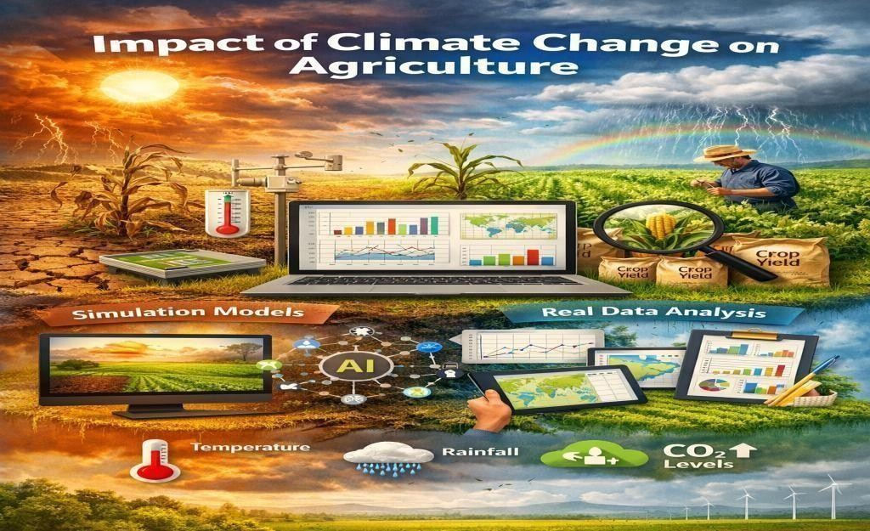
Figure 1.1. Architecture Image

1.2.Motivation to the Topic

Many economies rely heavily on agriculture, which is also essential to providing food security for the world's continuously expanding population. However, one of the biggest issues facing agricultural systems globally now is climate change. Crop production is becoming uncertain due to rising temperatures, erratic rainfall patterns, rising carbon dioxide emissions, and extreme weather events, endangering the lives of millions of farmers. Understanding how climatic factors affect agricultural output and how farmers may adjust to these challenges is crucial in light of these environmental changes.
The growing demand for data-driven decision-making in agriculture is the driving force for the choice of this subject. The consequences of climate change on agricultural output have been the subject of several research, however many of them mainly concentrate on theoretical justifications, simulation models, or particular climatic variables. Comprehensive statistical analyses that use actual data to assess the links between climate variables and agricultural productivity are becoming more and more necessary. The chance to close this gap by using statistical methods such as correlation analysis, regression analysis, ANOVA, trend analysis, and the Kruskal–Wallis test is what motivated this investigation.
The need to assess whether current adaptation techniques are successfully assisting farmers in maintaining productivity in the face of changing climatic circumstances is another significant driving force. Knowing how successful these tactics are can help create agricultural systems that are more robust and assist evidence-based decision-making for sustainable farming methods. The study's ulti mate objective is to assist future food security, enhance climate resilience, and promote sustainable agriculture through insightful data analysis and scientific research.

1.3 Significance and Need of the Study
One of the main issues affecting global food security and agricultural production is climate change. Crop growth, yield, and agricultural sustainability are all greatly impacted by variations in temperature, precipitation, and carbon dioxide (CO₂) emissions. This work is significant because it uses a real-world agricultural dataset to investigate the relationship between climate variables and agricultural productivity. Temperature, precipitation, CO2 emissions, irrigation availability, soil health, crop types, nations, regions, and adaptation tactics are all included in the dataset. To accomplish the research goals, statistical methods like Pearson Correlation
Analysis, Multiple Linear Regression, One-Way ANOVA, Trend Analysis, and the Kruskal– Wallis Test were used. These methods aid in determining correlations between crop output and climate variables, quantifying the impact of climate variables, comparing productivity among various groups, examining productivity trends over time, and assessing adaptation tactics. This study incorporates several statistical techniques into a single analytical framework, in contrast to numerous other studies that concentrated on specific climate parameters.The study fills in significant research gaps and offers a thorough grasp of the connections between climate and agriculture. The results can help farmers, legislators, academics, and agricultural planners make wise choices. Additionally, they support the advancement of sustainable agricultural management and climate-resilient farming techniques.
Overall, this work shows the value of statistical analysis in promoting future agricultural sustainability and advances knowledge of how particular climate variables affect agricultural output.

1.4. Problem Statement
Due to its substantial effects on agricultural production and food security, climate change has emerged as a major global concern. Crop growth, yield, and overall agricultural performance
can all be directly impacted by changes in climate variables like temperature, precipitation,
and carbon dioxide (CO₂) emissions. Farmers and politicians find it challenging to create
sustainable farming methods due to the increased uncertainty in agricultural productivity
caused by rising temperatures, erratic rainfall patterns, and shifting environmental circumstances.
While a number of studies have looked at how climate change affects agriculture, many of them mainly concentrate on theoretical debates, literature reviews, simulation models, or particular climatic aspects. Comprehensive statistical methods that concurrently examine the connections between climate factors, crop production, geographical variations, crop kinds, and adaptation techniques using actual agricultural data have only been used in a small number of studies.
Thus, the absence of an integrated statistical evaluation of the effects of climate change on agricultural productivity is the issue this work attempts to address. The objectives of this study are to compare productivity across various agricultural categories, analyze the relationship between climate variables and crop yield, assess the impact of climatic factors on productivity, look at productivity trends over time, and use appropriate statistical techniques to evaluate the efficacy of adaptation strategies.
In order to comprehend climate-related risks and create sustainable, climate-resilient agricultural practices, researchers, policymakers, agricultural planners, and farmers should find great value in the study's findings.
Additionally, it is necessary to ascertain which climatic factors have the biggest impact on agricultural productivity, whether productivity varies significantly between nations, regions, and crop types, how crop yield has changed over time, and whether current adaptation strategies successfully support productivity maintenance under changing climatic conditions.

1.5. Objectives of the Study
Objective 1: Relationship Analysis between Climate Variables and Agricultural Productivity.
Objective: To analyze the relationship between climate variables and agricultural productivity by examining how factors such as temperature, precipitation, carbon dioxide (CO₂) emissions, irrigation access, and soil health influence crop yield using Pearson Correlation Analysis.
Approach:
The relationship between climate variables and agricultural productivity is analyzed using Pearson Correlation Analysis. The agricultural dataset is first preprocessed by handling missing values, removing duplicate records, and ensuring data consistency. Climate-related variables such as average temperature, total precipitation, CO₂ emissions, irrigation access, and soil health index are considered, while crop yield is used as the measure of agricultural productivity. A correlation matrix is generated to calculate the strength and direction of relationships between the variables. To enhance interpretation, a correlation heatmap is created to visually represent the associations among climate factors and crop yield. This approach helps identify the climate variables that have the strongest positive or negative relationship with agricultural productivity and provides a foundation for further statistical analysis.
Objective 2: Impact Analysis of Climate Variables on Agricultural Productivity
Objective: To determine the impact of climate variables on agricultural productivity by identifying the extent to which factors such as temperature, precipitation, carbon dioxide (CO₂) emissions, irrigation access, and soil health influence crop yield using Multiple Linear Regression Analysis.
Approach:
The impact of climate variables on agricultural productivity is evaluated using Multiple
Linear Regression Analysis. The preprocessed agricultural dataset is utilized, where Average Temperature, Total Precipitation, CO₂ Emissions, Irrigation Access, and Soil Health Index are
considered as independent variables, while Crop Yield (MT per HA) is considered the dependent
variable. The regression model is trained to quantify the contribution of each climate-related factor
to crop yield and to identify the most influential variables affecting agricultural productivity. Model performance is evaluated using statistical metrics such as R² Score, Mean Absolute Error (MAE), and Root Mean Square Error (RMSE). The regression coefficients obtained from
the model help explain the direction and magnitude of the impact of each climate variable on
crop yield, providing a deeper understanding of the factors influencing agricultural productivity.
Objective 3: Comparison of Agricultural Productivity Across Different Categories Using
ANOVA
Objective: To compare agricultural productivity across different countries, regions, crop types, and adaptation strategies using Analysis of Variance (ANOVA) and determine whether significant differences exist in crop yield among these groups.
Approach:
Agricultural productivity is compared across multiple categorical factors using One-Way
Analysis of Variance (ANOVA). The preprocessed agricultural dataset is grouped based on Country, Region, Crop Type, and Adaptation Strategy, while Crop Yield (MT per HA) is considered the dependent variable. ANOVA is applied separately to each categorical variable to determine whether the mean crop yield differs significantly among the groups. The F-statistic and p-value are calculated to evaluate statistical significance, while Eta Squared (η²) is used to measure the effect size and the extent of variation explained by each factor. In addition, boxplots and visual comparisons are generated to examine the distribution of crop yield across different categories. This approach helps identify whether geographical location, crop type, or adaptation practices contribute to significant differences in agricultural productivity.
Objective 4: Trend Analysis of Agricultural Productivity Over Time
Objective: To examine trends in agricultural productivity over time by analyzing changes in crop yield and identifying long-term patterns associated with changing climatic conditions.
Approach:
Trend Analysis was performed to study the variation in agricultural productivity over different years. The preprocessed dataset was grouped based on the Year variable, and the average Crop Yield (MT per HA) was calculated for each year. A time-series line graph was generated to visualize changes in crop yield over time and identify increasing, decreasing, or stable productivity trends. The analysis focused on observing long-term patterns and fluctuations in agricultural productivity under changing climatic conditions. This approach helps in understanding how crop yield has evolved over time and provides insights into the overall impact of climate-related factors on agricultural production.
Objective 5: Evaluation of Adaptation Strategies on Agricultural Productivity Using the
Kruskal–Wallis Test
Objective: To evaluate whether adaptation strategies significantly influence agricultural productivity under changing climatic conditions using the Kruskal–Wallis Test.

Approach:
The effectiveness of different adaptation strategies on agricultural productivity is evaluated using the Kruskal–Wallis H Test, a non-parametric statistical technique. The preprocessed agricultural dataset is grouped based on different adaptation strategies, while Crop Yield (MT per HA) is considered the dependent variable. The Kruskal–Wallis test is applied to determine whether significant differences exist in crop yield among the adaptation strategy groups. The H-statistic and p-value are calculated to assess statistical significance, while a boxplot is generated to visualize the distribution of crop yield across different adaptation strategies. Additionally, Epsilon Squared (ε²) may be calculated to measure the effect size and evaluate the practical significance of the observed differences. This approach helps assess the effectiveness of adaptation strategies in maintaining agricultural productivity under changing climatic conditions.
1.6. Chapter -Wise Summary

Chapter 1: Introduction
This chapter presented the influence of climate change on agricultural productivity and stressed the importance of agriculture for food security and sustainable development. It covered how crop output and agricultural sustainability are impacted by climate variables as temperature, precipitation, and CO2 emissions. The motivation, importance, problem statement, research goals, and study scope were all presented in this chapter. In order to comprehend the connection between climate variables and agricultural productivity, it also underlined the necessity of statistical analysis. All things considered, this chapter laid the groundwork for the investigation and described the course of the next chapters.

Chapter 2: Literature Review
This chapter examined a collection of research on how climate change affects agricultural productivity, with particular attention to variables including temperature, precipitation, CO2 emissions, and climate variability. To detect study gaps, the methods, conclusions, advantages, and disadvantages of earlier studies were carefully examined. According to the review, there aren't many research that combine several statistical methods into one framework. In order to fully examine agricultural productivity, the current study used Pearson Correlation Analysis, Multiple Linear Regression, ANOVA, Trend Analysis, and the Kruskal–Wallis Test. All things considered, the literature review supplied the theoretical underpinning and rationale for the research approach employed in this investigation.

Chapter 3: Data Domain
The Climate Change Impact on Agriculture 2024 dataset, which included 10,000 records and 15 variables pertaining to climate and agricultural parameters, was summarized in this chapter. It explained the features and structure of the dataset as well as how each attribute related to the goals of the study. Additionally covered were data preprocessing procedures such as feature selection, duplicate verification, missing value checking, and data inspection. The dataset was shown to be trustworthy and appropriate for statistical analysis in this chapter. All things considered, it created a solid basis for utilizing the statistical methods employed in the following chapters.

Chapter 4:Statistical Tools and Software Used
The software tools, Python libraries, and statistical techniques used to examine how climate change affects agricultural productivity were covered in this chapter. Data processing, analysis, and visualization were done using Python, Jupyter Notebook, and Microsoft Excel; the analytical process was aided by libraries like Pandas, NumPy, Matplotlib, Seaborn, Scikitlearn, and SciPy. Prior to performing more complex analysis, basic statistical methods were used for data preparation and exploration. To accomplish the goals of the study, sophisticated statistical techniques such as Pearson Correlation Analysis, Multiple Linear Regression, ANOVA, Trend Analysis, and the Kruskal–Wallis Test were employed. All things considered, this chapter created the analytical foundation necessary for a trustworthy and insightful assessment of the connection between climate factors and agricultural productivity.

Chapter 5: Data Visualisation

The statistical analyses conducted to examine the effects of climate change on agricultural productivity were graphically visualized in this chapter. The associations between climate factors and crop yield were interpreted using visualizations such correlation heatmaps, scatter plots, regression coefficient plots, boxplots, and trend graphs. According to the findings, the most significant factor influencing agricultural productivity was average temperature. While Trend Analysis demonstrated comparatively consistent agricultural output over time, ANOVA and Kruskal-Wallis visualizations revealed no statistically significant variations in crop yield between the examined groups. Overall, the study's research goals and statistical results were successfully supported by the visualizations.

Chapter 6: Exploratory Data Analysis (EDA)
This chapter presented the Exploratory Data Analysis (EDA) performed on the Crop Yield Prediction Dataset used in this study. The chapter began with an introduction to EDA, highlighting its importance in understanding the dataset and preparing it for statistical analysis. A comprehensive dataset overview was then provided, describing the dataset source, structure, variables, and characteristics relevant to the research objectives. Data quality assessment confirmed that the dataset was complete, with no missing values or duplicate records, and that all variables were stored using appropriate data types. Descriptive statistics summarized the central tendency, variability, and distribution of the numerical variables, providing an overall understanding of the dataset.
Exploratory visualizations, including histograms and boxplots, were used to examine the distribution of important variables and identify potential outliers. The EDA results demonstrated that the dataset was clean, consistent, reliable, and well-structured for further analysis. Overall, this chapter established a strong foundation for applying Correlation Analysis, Multiple Linear Regression, ANOVA, Trend Analysis, and the Kruskal–Wallis Test in the subsequent chapters to investigate the impact of climate change on agricultural productivity and achieve the research objectives.

Chapter 7: Model Building/Advanced Data Analysis Techniques
This chapter examined how climate change affects agricultural productivity using sophisticated statistical methods. Pearson Correlation and Multiple Linear Regression identified Average
Temperature as the most relevant factor determining crop yield. One-Way ANOVA and the Kruskal–Wallis Test found no statistically significant variations in crop output across the category groups studied. According to trend analysis, there were only slight variations in agricultural productivity during the studied period. Overall, the statistical analyses successfully addressed all five research objectives and validated the findings of the study.

Chapter 8: Conclusions and Future Scope
This chapter concluded that the chosen climate factors have varied degrees of impact on agricultural productivity after summarizing the study's overall findings. All five research objectives were satisfactorily met by the statistical analyses, and the most significant climate variable influencing crop yield was found to be average temperature. The practical implications of the results for evidence-based decision-making and sustainable agriculture were also emphasized in the chapter. In general, the chapter highlighted the value of statistical analysis in comprehending the connections between agriculture and climate change and promoting sustainable agricultural development.

Chapter 9: Appendix
This chapter includes the extra materials that complement the research activity and provide further specifics of the investigation. It contains all of the Python programs needed for statistical studies including Pearson Correlation, Multiple Linear Regression, ANOVA, Trend Analysis, and the Kruskal–Wallis Test, as well as data pretreatment and visualization. Important results, tables, graphs, and other supporting data that weren't covered in the major chapters are also included in the appendix. These resources enhance the research's reproducibility and transparency. All things considered, the appendix functions as a reference part that bolsters the approach and findings discussed throughout the dissertation.

2. REVIEW OF THE LITERATURE

2.1 Introduction
Climate change has become one of the most significant global challenges affecting agricultural productivity and food security. Changes in temperature, precipitation patterns, carbon dioxide (CO₂) emissions, and other climatic factors have a direct impact on crop growth, yield, and agricultural sustainability. As a result, researchers across the world have conducted extensive studies to understand the relationship between climate change and agricultural production.
The review of literature is an important part of research as it provides an understanding of previous studies, methodologies, findings, and existing research gaps. Several studies have examined the effects of climate variables on crop yield using different approaches such as statistical analysis, climate simulation models, regression techniques, and predictive modeling. These studies have highlighted the importance of climate factors in determining agricultural productivity and emphasized the need for adaptation strategies to reduce climate-related risks.
The selected base papers for this study focus on the impacts of climate change on agricultural production, crop yield variability, and adaptation measures. These studies provide valuable insights into how changing climatic conditions influence agricultural systems across different regions and crops. However, most of the existing research primarily focuses on literature reviews, simulation-based approaches, threshold analysis, and large-scale climate assessments.
A limited number of studies have applied multiple statistical techniques within a single framework to comprehensively evaluate climate variables, crop yield, productivity differences, temporal trends, and adaptation strategies using real-world agricultural data. Therefore, there is a need for a detailed statistical investigation that provides measurable and practical insights into climate-agriculture interactions.
To address this gap, the present study applies Pearson Correlation Analysis, Multiple Linear Regression, ANOVA, Trend Analysis, and the Kruskal–Wallis Test to examine the impact of climate change on agricultural productivity. The literature reviewed in this chapter provides the theoretical foundation for the study, identifies limitations in previous research, and justifies the objectives and methodology adopted for the present work.
2.2 Review of Existing Research Works

Paper 1
Title: Impacts of Global Climate Change on Agricultural Production: A Comprehensive
Review
Authors: Xiangning Yuan, Sien Li, Jinliang Chen, Haichao Yu, Tianyi Yang, Chunyu Wang,
Siyu Huang, Haochong Chen, Xiang Ao
Year: 2024
Methodology: Comprehensive literature review of recent studies on climate change and agriculture. Examined impacts of temperature, precipitation, extreme weather events, pests, diseases, soil degradation, and adaptation measures.
Findings: The study found that climate change significantly affects crop growth cycles, crop yield, quality, soil health, water resources, and food security. It emphasized the importance of sustainable agricultural practices and adaptation strategies to reduce climate-related risks.

Paper 2
Title: Climate Change Impacts on Crop Yields Across Temperature Rise Thresholds and
Climate Zones
Authors: Bao-Linh Tran, Wei-Chun Tseng, Chi-Chung Chen
Year: 2025
Methodology: Threshold Regression Analysis, Mixed-Effects Models, Meta-analysis using global crop simulation datasets.
Findings: The study identified critical temperature thresholds beyond which crop yields decline rapidly. Wheat, rice, and maize showed significant yield reductions under increasing temperatures, particularly in arid climate zones. Adaptation measures helped reduce yield losses under climate stress.

Paper 3
Title: Climate Variation Explains a Third of Global Crop Yield Variability
Authors: Deepak K. Ray, James S. Gerber, Graham K. MacDonald, Paul C. West
Year: 2015
Methodology: Climate variability analysis using crop yield datasets from approximately 13,500 political units worldwide. Statistical modeling and F-tests were used to examine the relationship between climate variability and crop yields.
Findings: Results showed that climate variability accounts for approximately 32–39% of global crop yield variability. Temperature and precipitation variations were identified as major contributors to fluctuations in agricultural productivity.

Paper 4
Title: Impacts of Recent Climate Change on Crop Yield Can Depend on Local Conditions in
Climatically Diverse Regions of Norway
Authors: Shirin Mohammadi, Knut Rydgren, Vegar Bakkestuen, Mark A.K. Gillespie Year: 2023
Methodology: Linear Mixed Effects Models and LASSO Regression using county-level crop yield and climate data from Norway (1980–2019).
Findings: The study revealed that the impact of climate variables on crop yield differs significantly across regions due to local climatic conditions. Temperature increases benefited some regions while negatively affecting others, highlighting the importance of regional adaptation planning.

Paper 5
Title: Climate Change Has Likely Already Affected Global Food Production
Authors: Deepak K. Ray, Paul C. West, Michael Clark, James S. Gerber, Alexander V.
Prishchepov, Snigdhansu Chatterjee
Year: 2019
Methodology: Statistical yield models using weather and crop production data across approximately 20,000 political units globally. Linear regression techniques were employed to estimate climate impacts on crop production.
Findings: The study found that climate change has already affected global food production. Yield impacts varied across crops and regions, with negative effects observed in Europe, Southern Africa, and Australia, while some positive effects were observed in Latin America.

2.3. Comapartive Analysis of Reviewed Studies
The research papers that have been evaluated offer insightful information about how climate change affects agricultural productivity. The relationship between climatic conditions and crop production has been investigated using a variety of approaches, including literature reviews, threshold regression models, mixed-effects models, climate variability analysis, and statistical yield modeling. These studies demonstrate how temperature, precipitation, and climate fluctuation have a substantial impact on agricultural productivity across many areas and crops. Still, the majority of current research concentrates on certain elements like yield variability, climate thresholds, or regional evaluations. Conducting a thorough statistical review employing several analytical techniques inside a single framework has received little attention. Additionally, comparisons between nations, areas, crop varieties, and adaptation techniques are rarely thoroughly investigated. In order to determine the strengths, weaknesses, and research gaps of the examined papers, a comparative analysis was carried out. The analysis's conclusions serve as the basis and rationale for the current investigation.
Comparison table
Paper /  Method | Model  Used | Key Features | Strengths | Limitations
Impacts of  Global Climate  Change on  Agricultural  Production: A  Comprehensive  Review (2024) | Literature Review  Framework | Examined the  effects of temperature, precipitation, CO₂ emissions, extreme weather events, soil health, and adaptation strategies on agriculture. | Provides a  comprehensive  overview of climate change  impacts on agricultural  production and food security. | Does not perform statistical analysis on real agricultural  datasets and lacks  quantitative evaluation of  climate-productivity  relationships.
Climate  Change  Impacts on  Crop Yields  Across  Temperature  Rise Thresholds and Climate Zones (2025) | Threshold  Regression,  Mixed-  Effects  Models,  Meta-  Analysis | Analyzed crop yield responses under different temperature rise thresholds and climate zones using simulation datasets. | Identifies critical temperature thresholds affecting crop yields and provides climatezonespecific insights. | Focuses mainly on temperature effects and simulation- based analysis; does not compare countries, regions, crop types, or adaptationstrategies statistically.
Climate  Variation  Explains a  Third of Global  Crop  Yield  Variability  (2015) | Climate  Variability Models,  Statistical  Yield  Analysis | Examined the influence of temperature and  precipitation  variability on global crop yields across multiple regions. | Demonstrates the significant contribution of climate variability to crop yield  fluctuations worldwide. | Primarily focuses on climate variability and does not evaluate adaptation strategies or productivity differences among groups.
Impacts of  Recent Climate  Change on  Crop  Yield in  Climatically  Diverse  Regions of  Norway  (2023) | Linear  Mixed  Effects  Models  (LMM),  LASSO  Regression | Investigated the relationship between temperature, precipitation, and crop yield at county level in  Norway. | Highlights the importance of local climatic  conditions and regional  differences in crop productivity. | Study is geographically limited to Norway and a few selected crops, reducing global applicability.
Climate  Change  Has Likely  Already  Affected  Global Food  Production  (2019) | Statistical  Yield  Models,  Linear  Regression  Analysis | Assessed the impact of  observed climate change on global food production using crop and  weatherdatasets. | Provides largescale evidence that climate change  has already affected agricultural production worldwide. | Focuses on production impacts and does not statistically compare productivity across regions, crop types, or adaptation strategy groups.
Table:2.3.1

Analytical Discussion
The studied literature emphasizes how climate change significantly affects agricultural productivity in many crop systems and geographical areas. The majority of research found that crop output and food security are significantly influenced by temperature, precipitation, and climate variability. The examined publications used a variety of techniques, such as statistical yield analyses, threshold regression models, mixed-effects models, literature reviews, and assessments of climate variability. These studies highlight the need for practical adaptation methods and offer insightful information about how shifting climate conditions affect
agricultural productivity.
A thorough examination, however, shows that many research concentrate on particular facets of climate change, such as regional yield variability, temperature thresholds, or simulationbased estimates. There hasn't been much research done utilizing several statistical methods in one analytical framework. Additionally, there is still a lack of research on comparisons of agricultural productivity between nations, geographies, crop kinds, and adaptation strategy groupings. Additionally, statistical testing is rarely used to assess the success rate of adaption measures. Consequently, there is a research gap in using real-world datasets to provide a thorough statistical evaluation of the effects of climate change on agriculture. In order to close this gap, the current study combines correlation analysis, multiple linear regression, ANOVA, trend analysis, and the Kruskal-Wallis test to offer a thorough assessment of agricultural productivity trends and climate-agriculture linkages.

2.4. Summary
The literature study looked at earlier research on how climate change affects agricultural output, with a particular emphasis on climate factors like temperature, precipitation, CO2 emissions, and climate variability. It examined a number of approaches, such as climatic variability analysis, regression techniques, and statistical models. The results demonstrated that climate change considerably affects crop output and agricultural productivity across different locations and crop kinds. However, rather of using a thorough statistical framework, the majority of previous research concentrated on specific elements. In order to give a thorough statistical analysis based on the identified research gaps, this study used Pearson Correlation Analysis,
Multiple Linear Regression, ANOVA, Trend Analysis, and the Kruskal–Wallis Test.

3. DATA DOMAIN

3.1. Introduction
Data is essential for comprehending how climate change influences agricultural productivity. The dataset's quality and relevance are key factors that determine the precision and dependability of the analysis. This chapter provides an in-depth overview of the dataset utilized in this research, outlining its domain, structure, attributes, and importance. The dataset includes climate-related variables such as temperature, precipitation, and carbon dioxide (CO₂) emissions, as well as agricultural variables like crop yield, crop type, soil health, irrigation access, and adaptation strategies.
The chosen dataset offers crucial insights for exploring how climatic conditions affect agricultural productivity in various countries and regions. The study seeks to uncover patterns, trends, and factors that impact crop yields as environmental conditions evolve by examining these variables. This chapter further details the dataset's characteristics, provides an in-depth description of each attribute, and emphasizes its importance in meeting the research objectives. Grasping the dataset is vital for choosing suitable statistical methods and ensuring the results from the subsequent analysis are interpreted meaningfully.

3.2 Domain Overview
The dataset analyzed in this research pertains to the field of Climate Change and Agriculture, with a focus on examining how shifts in the environment impact agricultural output and food security. Agriculture is highly susceptible to climate fluctuations, as elements like temperature, precipitation, CO₂ concentrations, and severe weather events directly influence crop growth and yields. Variations in these climatic factors can modify crop development, decrease productivity, and heighten the risk of food scarcity. In recent times, climate change has posed significant challenges to agricultural sustainability, marked by increasing global temperatures, erratic rainfall, droughts, floods, and other environmental issues. These climatic shifts not only affect crop yields but also have repercussions for soil health, water resources, irrigation needs, and farming methods. Thus, comprehending the link between climate variables and agricultural productivity is crucial for formulating effective adaptation and mitigation strategies.
In order to investigate how climate conditions affect farming systems, the climate and agriculture domain integrates environmental science, agricultural science, and data analytics. Researchers can discover important factors impacting productivity and promote evidencebased decision-making by combining the analysis of agricultural and climate-related variables. The dataset utilized in this study is appropriate for statistical analysis of the effects of climate change on agricultural productivity since it offers useful information for analyzing these relationships across various nations, regions, crop kinds, and adaption techniques.

3.3. Sample Dataset Description
Source: The dataset used in this study is the "Climate Change Impact on Agriculture 2024" dataset obtained from the Kaggle platform. It is a structured dataset containing 10,000 records and 15 attributes related to climate, agriculture, geography, adaptation strategies, and economic impact. The dataset was selected because it provides comprehensive information required to analyze the relationship between climate change and agricultural productivity. It includes variables such as temperature, precipitation, CO₂ emissions, crop yield, irrigation access, and soil health. Therefore, it is highly suitable for achieving the objectives of this research.
Dataset link: https://www.kaggle.com/datasets/patelris/crop-yield-prediction-dataset/code
The "Climate Change Impact on Agriculture 2024" dataset, which falls within the Climate Change and Agriculture domain, was utilized in this investigation. The purpose of the dataset is to examine how agricultural, meteorological, and environmental factors affect crop productivity in various nations and areas. It includes organized tabular data that illustrates agricultural output in various climates.
With 10,000 records and 15 variables, the dataset offers a thorough understanding of the relationships between climate change and agriculture. Temperature, precipitation, carbon dioxide (CO₂) emissions, irrigation availability, soil health, fertilizer and pesticide use, adaptation tactics, and economic effects are all included. These factors support statistical study of crop yield patterns and aid in understanding how climate change affects agricultural output.
The study's aim variable is crop yield (MT per HA), which is regarded as the main measure of agricultural productivity. Environmental effects on agricultural production are examined using climate variables such CO2 emissions, total precipitation, and average temperature. Farming methods and resource availability are revealed by agricultural variables such as Soil Health Index, Fertilizer Use, Pesticide Use, and Irrigation Access. Additionally, while adaptation strategies aid in assessing the efficacy of climate adaption measures, geographical characteristics like country and region allow for comparison study across various areas. Because it incorporates meteorological, agricultural, topographical, and economic aspects into a unified framework, the dataset is ideal for examining how climate change affects agriculture. It facilitates the use of statistical methods to accomplish the study's goals, including correlation analysis, multiple linear regression, ANOVA, trend analysis, and the Kruskal–Wallis test.

3.4 Dataset Characteristics
Property | Description
Dataset Name | Climate Change Impact on Agriculture 2024
Dataset Domain | Climate Change and Agriculture
Dataset Type | Structured Tabular Dataset
Property | Description
Number of Records | 10,000
Number of Attributes | 15
File Format | CSV
Target Variable | Crop Yield (MT per HA)
Analysis Type | Statistical Analysis
Study Focus | Impact of Climate Change on Agricultural  Productivity
Table:3.4.1

3.4.1. Attributes in Dataset
Attribute | Description
Year | Year of observation
Country | Country where agricultural activity was recorded
Region | Geographical region
Crop_Type | Type of crop cultivated
Average_Temperature_C | Average temperature in Celsius
Total_Precipitation_mm | Total annual precipitation in millimeters
CO2_Emissions_MT | Carbon dioxide emissions in metric tons
Attribute | Description
Crop_Yield_MT_per_HA | Crop yield in metric tons per hectare
Extreme_Weather_Events | Number of extreme weather events
Irrigation_Access_% | Percentage of irrigation access
Pesticide_Use_KG_per_HA | Pesticide usage per hectare
Fertilizer_Use_KG_per_HA | Fertilizer usage per hectare
Soil_Health_Index | Indicator of soil quality
Adaptation_Strategies | Climate adaptation measures adopted
Economic_Impact_Million_USD | Economic impact in million USD
Table:3.4.1.1

3.5 Feature Categorization
The attributes present in the dataset can be categorized into different groups based on their role in the study.

Climate Features
- Average Temperature (°C)
- Total Precipitation (mm) • CO₂ Emissions (MT)
- Extreme Weather Events

Agricultural Features
- Crop Yield (MT per HA)
- Irrigation Access (%)
- Fertilizer Use (KG per HA)
- Pesticide Use (KG per HA)
- Soil Health Index

Geographical Features
- Country
- Region
Crop Feature
- Crop Type
Adaptation Feature
- Adaptation Strategies

Economic Feature
• Economic Impact (Million USD)
These feature categories provide a comprehensive representation of climatic, agricultural, geographical, and economic factors affecting agricultural productivity.

3.6 Sample Dataset Records
Inserted 5–10 rows from actual dataset screenshot.
Year | Country | Crop Type | Avg Temp | Crop Yield
2001 | India | Corn | 1.55 | 1.737
2024 | China | Corn | 3.23 | 1.737
2001 | France | Wheat | 21.11 | 1.719
2001 | Canada | Coffee | 27.85 | 3.890
1998 | India | Sugarcane | 2.19 | 1.080
Table:3.6.1
3.7. Dataset Relevance to Research Objectives
Objective | Dataset Attributes Used
Objective 1 | Temperature, Precipitation, CO₂ Emissions, Irrigation Access, Soil  Health Index, Crop Yield
Objective 2 | Temperature, Precipitation, CO₂ Emissions, Irrigation Access, Soil  Health Index, Crop Yield
Objective 3 | Country, Region, Crop Type, Adaptation Strategies, Crop Yield
Objective 4 | Year, Crop Yield
Objective | Dataset Attributes Used
Objective 5 | Adaptation Strategies, Crop Yield
Table.3.7.1
3.8 Summary
A thorough description of the dataset used to examine how climate change affects agricultural productivity can be found in the Data Domain chapter. The Climate Change Impact on Agriculture 2024 dataset, which includes 10,000 records and 15 variables representing climatic, agricultural, geographical, adaptability, and economic elements, is used in this study. To provide a clear understanding of the data, the chapter explains feature categorization, attribute information, domain knowledge, and dataset characteristics. Climate-agriculture links were examined by analyzing key variables such temperature, precipitation, CO2 emissions, irrigation access, soil health, crop output, and adaption techniques. To guarantee data quality and consistency, preprocessing methods such as feature selection, duplicate checking, dataset inspection, and missing value verification were carried out.

4.STATISTICAL TOOLS AND SOFTWARE USED

4.1 Introduction
In order to convert unprocessed data into useful information and facilitate data-driven decisionmaking, statistical software and tools are essential. The influence of climate change on agricultural productivity was examined in this study using a variety of statistical methods, software tools, and computer libraries. Effective data pretreatment, analysis, visualization, and result interpretation are made possible by the use of the right tools. Python's broad support for statistical computing and data research led to its selection as the main programming language. An interactive platform for carrying out and recording the analysis process was made available by Jupyter Notebook. To carry out various analytical tasks, a number of specialized libraries were used, including Pandas, NumPy, Matplotlib, Seaborn, Scikit-learn, and SciPy. To accomplish the study's goals, both fundamental and sophisticated statistical methods were used.
While sophisticated techniques were employed to look into relationships, trends, group differences, and the efficacy of adaption strategies, basic tools were used for data handling, descriptive analysis, and visualization. The study's primary analytical framework consisted of Pearson Correlation Analysis, Multiple Linear Regression, ANOVA, Trend Analysis, and the Kruskal–Wallis Test. These techniques made it easier to comprehend how climate variables affect agricultural productivity from a variety of angles. Reliable analysis, correct interpretation, and significant insights into the connection between climate change and agricultural productivity were guaranteed by the integration of statistical methods and software. 4.2. Software Used

Python
Python was used as the primary programming language for implementing the project. It provides
powerful libraries and tools for data analysis, statistical computing, machine learning,
and visualization. Python enabled efficient processing of the agricultural dataset and execution of
all statistical techniques used in the study.

Jupyter Notebook
Jupyter Notebook served as the development and execution environment for the project. It allowed interactive coding, visualization of outputs, and documentation of the analytical process in a single platform. The notebook environment made it easier to organize the workflow and interpret the
results.

Pandas
Pandas was used for data loading, preprocessing, cleaning, and manipulation. It provided efficient data structures such as DataFrames that simplified handling of the 10,000-record dataset. Feature selection, grouping, filtering, and aggregation operations were performed using Pandas.

NumPy
NumPy was utilized for numerical and mathematical computations. It supported array operations, statistical calculations, and mathematical functions required for data analysis and model evaluation.

Matplotlib
Matplotlib was used to create visual representations of the data and analytical results. Trend graphs and other plots generated through Matplotlib helped in understanding productivity patterns and presenting findings effectively.
Seaborn
Seaborn was used for advanced statistical visualization. It was primarily employed to generate the correlation heatmap and boxplots used in the study. The library enhanced the visual interpretation of relationships and group comparisons within the dataset.

Scikit-learn

Scikit-learn was used to implement the Multiple Linear Regression model. It also provided evaluation metrics such as R² Score, Mean Absolute Error (MAE), and Root Mean Square Error (RMSE), which were used to assess the regression model's performance.

SciPy

SciPy was used to perform statistical hypothesis testing. It was specifically utilized for conducting ANOVA and the Kruskal–Wallis Test, which helped evaluate differences among groups and adaptation strategies.

Microsoft Excel

Microsoft Excel was used for preliminary dataset inspection, verification, and understanding of data structure. It assisted in reviewing records, checking attribute values, and validating the dataset before conducting statistical analysis.

4.2.1. Python Libraries Used
Library | Purpose
Pandas | Data loading, preprocessing, and manipulation
NumPy | Numerical and mathematical computations
Library | Purpose
Matplotlib | Graph plotting and visualization
Seaborn | Statistical visualization and heatmaps
Scikit-learn | Multiple Linear Regression and evaluation metrics
SciPy | ANOVA and Kruskal–Wallis statistical tests
Table 4.2.1.1

4.3. Basic Statistical Tools Used
Basic statistical tools were used to understand the dataset, characterize its properties, and prepare it for more intricate statistical analysis. These techniques provided a fundamental understanding of the data distribution, variable behavior, and overall dataset quality. Applying basic statistical processes is essential to identify trends, identify discrepancies, and ensure that the data is suitable for further research.

1. Descriptive Statistics
Descriptive statistics were used to summarize the dataset's main characteristics. Measures such as mean, median, minimum, maximum, standard deviation, and count were calculated for a number of numerical variables, including temperature, precipitation, CO2 emissions, irrigation access, soil health index, and crop production. The variability and fundamental tendency of the data were easier to understand thanks to these measurements.

2.Data Inspection and Exploration
The dataset was examined using functions such data types, attribute information, and data shape. This step provided details about the attributes, number of records, and structure of the dataset. It also helped identify the numerical and categorical variables in the study.

3. Missing Value Analysis
The dataset was examined for null or missing values to ensure the data was full. Missing value analysis helped determine whether additional preprocessing techniques were required prior to statistical analysis. The dataset was found to be sufficiently comprehensive for further analysis. 4. Feature Selection
Relevant features were selected based on the study's objectives. Agricultural characteristics like crop production, irrigation availability, and soil health index, as well as climate variables like temperature, precipitation, and CO2 emissions, were selected for in-depth research.

5. Data Grouping and Aggregation
Using grouping and aggregating techniques, data was organized by nations, regions, crop types, adaptation strategies, and years. Comparing and analyzing trends across numerous categories became simpler as a result.

6. Data Visualization
Using basic visualization tools, the dataset was examined and understood. Using graphic representations such as line plots, bar charts, boxplots, and heatmaps made it easier to identify trends, patterns, and correlations between variables. Visualization also helped with the
interpretation of statistical results.
These basic statistical methods provided a strong foundation for the more advanced analytical methods used later in the study. They ensured data quality, improved understanding of the dataset, and encouraged appropriate interpretation of the results.

4.3.1. Advanced Statistical Methods Used
The project utilizes five advanced statistical methods to achieve the research objectives.

Method 1: Pearson Correlation Analysis

Purpose: To measure the strength and direction of the relationship between climate variables and crop yield.

Procedure

- Select climate variables and crop yield.
- Calculate Pearson correlation coefficients.
- Generate a correlation matrix.
- Visualize results using a heatmap.
- Interpret positive and negative relationships.

Output
- Correlation Matrix
- Heatmap
- Correlation Coefficient (r)

Method 2: Multiple Linear Regression

Purpose: To examine the combined impact of climate variables on agricultural productivity.

Procedure

- Select independent variables.
- Select crop yield as the dependent variable.
- Split data into training and testing sets.
- Train the regression model.
- Evaluate using R², MAE, and RMSE.

Output
- Regression Model
- R² Score
- MAE
- RMSE

Method 3: Analysis of Variance (ANOVA)

Purpose: To compare agricultural productivity across countries, regions, crop types, and adaptation strategies.

Procedure

- Group crop yield data.
- Calculate between-group and within-group variation.
- Compute F-statistic.
- Determine statistical significance using p-value.

Output
- F-statistic
- p-value
- Eta Squared (η²)

Method 4: Trend Analysis

Purpose: To identify long-term changes in agricultural productivity over time.

Procedure
- Group crop yield by year.
- Calculate yearly average yield.
- Plot trend graph.
- Determine trend slope.

Output
- Trend Plot
- Trend Slope

Method 5: Kruskal–Wallis Test

Purpose: To evaluate whether adaptation strategies significantly influence agricultural
productivity.

Procedure

- Divide data based on adaptation strategies.
- Rank observations.
- Compute H-statistic.
Determine significance using p-value.

Output
- H Statistic
- p-value
- Epsilon Squared (ε²)

4.3.2. Model Evaluation Techniques

Method | Evaluation Measure
Correlation Analysis | Correlation Coefficient (r)
Multiple Linear Regression | R², MAE, RMSE
ANOVA | F-statistic, p-value, Eta Squared
Trend Analysis | Trend Slope
Kruskal–Wallis Test | H Statistic, p-value, Epsilon Squared
Table 4.3.2.1

4.4 Summary
The software, Python libraries, and statistical methods utilized to examine how climate change affects agricultural productivity were covered in this chapter. For data processing, visualization, and statistical analysis, Python, Jupyter Notebook, and libraries including Pandas, NumPy, Matplotlib, Seaborn, Scikit-learn, and SciPy were utilized. Before doing more complex analyses, basic statistical techniques were used for data pretreatment and exploratory analysis.
Using evaluation metrics including R2 MAE, RMSE, F-statistic, p-value, Eta Squared, and H
Statistic, the study used Pearson Correlation Analysis, Multiple Linear Regression, ANOVA, Trend Analysis, and the Kruskal-Wallis Test. All things considered, these methods and instruments provide a trustworthy analytical framework for accomplishing the study's goals and deciphering the connection between climate factors and agricultural productivity.

5.DATA VISUALIZATION

5.1. Introduction
Data visualization, which enables the graphical and understandable representation of complicated information, is a crucial component of data analysis. By transforming vast quantities of numerical data into perceptive visual patterns, trends, and connections, it promotes effective analysis and decision-making. Understanding how climate conditions impact agricultural productivity in the context of climate change and agriculture requires data visualization. Visual representations aid researchers in identifying hidden patterns, comparing variables, and clearly communicating findings as compared to tabular data alone. In this study, data visualization tools were used to examine and analyze the relationships between climate factors and crop productivity. A range of graphical tools were used to complement the statistical analysis and provide a clear understanding of the dataset.
Visualizations such correlation heatmaps, trend graphs, and boxplots were developed to examine relationships, identify temporal patterns, and compare productivity across different adaptation strategies. These graphic results enhanced understanding of the data and supported the statistical methods employed in the investigation. Thanks to the use of visualization tools, analytical data were also verified and presented in a more comprehensible manner. All things considered, data visualization was an essential tool for analyzing the connections between agricultural and climate change and deriving important conclusions from the dataset. 5.2
Visualization Tools Used

Matplotlib
Matplotlib is a well-known Python library for creating graphical data visualizations. This project used Matplotlib to construct trend graphs and line plots to examine changes in agricultural productivity over time. The library included a range of visualization options that facilitated the successful and straightforward display of statistical results.

Seaborn
Matplotlib was used to create the Seaborn statistical data visualization package. It was used to create complex visualizations such as correlation heatmaps and boxplots. Seaborn helped determine relationships between agricultural output and climatic variables and evaluated productivity distributions across different adaptation strategies.

Pandas Visualization
Rapid exploratory data exploration is made possible by Pandas's integrated visualization tools. It was used to make basic graphs and search for patterns in the dataset in the early phases of research. Pandas visuals made it easy to understand the data's distribution and structure.

Jupyter Notebook
Jupyter Notebook was the visualization tool utilized to produce and display all graphs, charts,
and analytical results. It enabled interactive exploration of visualizations and efficient
data analysis throughout the research.
Visualization Tool | Purpose in Project
Matplotlib | Trend graphs and line plots
Seaborn | Correlation heatmaps and boxplots
Pandas Visualization | Basic exploratory plots and data analysis
Jupyter Notebook | Visualization environment and output display
Table 5.2.1
5.2.1. Correlation Heatmap Visualization
Objective
To visualize relationships between climate variables and crop yield.

Justification
A heatmap gives a clear visual depiction of correlation coefficients and helps discover variables that are highly connected with agricultural productivity.
Output

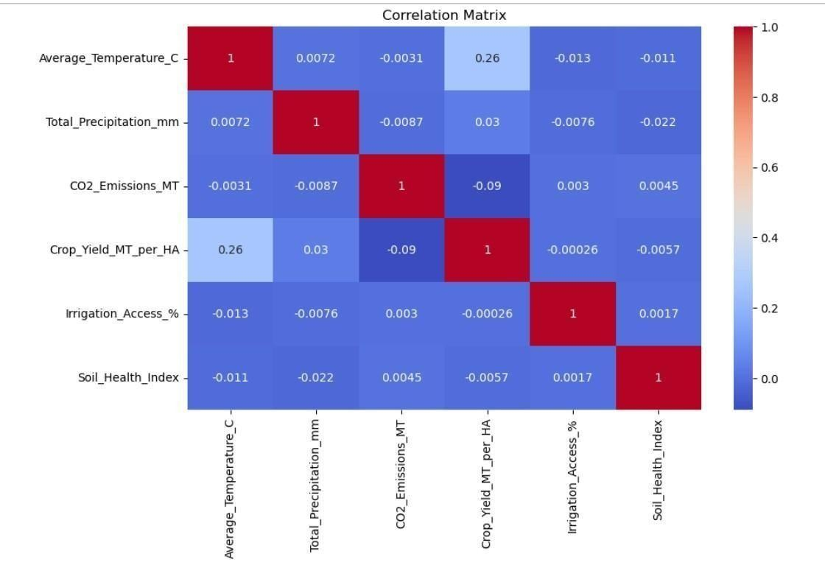
figure.5.2.1.1. Matrix Visualization of Correlation Matrix

Observation
- Crop yield and average temperature had the strongest positive connection (r = 0.264).
- There is a slight negative connection (r = -0.09) between CO2 emissions.
- There is a little positive connection (r = 0.03) with total precipitation.
- There is very little association between the Soil Health Index and Irrigation Access.

Interpretation
- The strongest positive correlation (r = 0.264) was found between temperature and crop yield.
- There was a weakly positive correlation with precipitation.
- There was a slight negative correlation with CO2 emissions.
- There was little correlation between soil health and irrigation access. Conclusion
According to the statistics, temperature has the greatest impact on agricultural productivity.

5.2.2. Regression Analysis Visualization
Objective
To analyze the impact of climate variables on crop yield.

Justification
Regression results are useful for assessing forecast performance and quantifying the influence of climate variables.

Observation
- The greatest positive coefficient is found in temperature.
- The biggest negative coefficient is found in CO2 emissions.
- The coefficients of other variables are relatively tiny.
- The model's R2 value is 0.0679.

Interpretation
- Crop output is influenced by a variety of climate factors.
- The model's R2 score was roughly 0.0679.
- A fraction of the variation in agricultural productivity can be explained by climate variables. Output

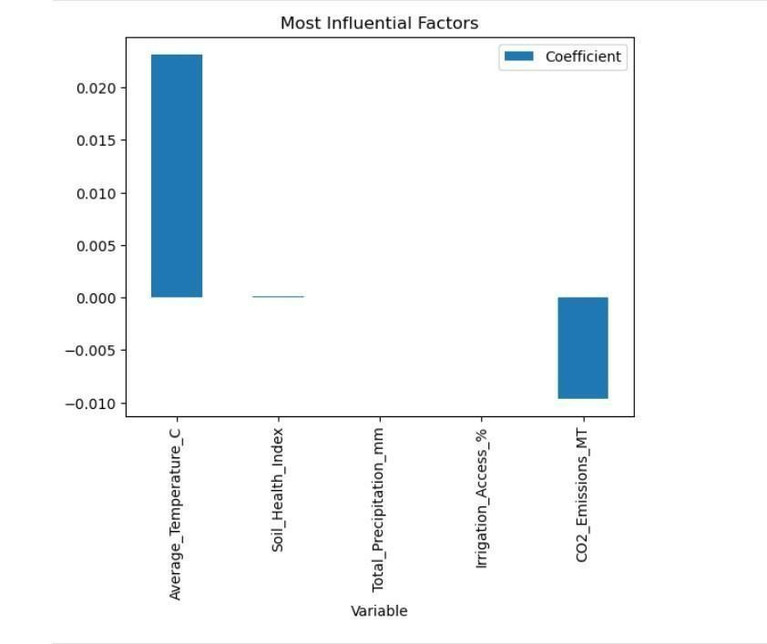 Figure.5.2.2.1. Linear Regression

Conclusion
Regression analysis verifies that variations in agricultural yield are influenced by climate conditions.

5.2.3. Boxplot Visualization for ANOVA

Objective
To visually compare agricultural productivity across different groups such as countries, regions, crop types, and adaptation strategies.

Justification
A boxplot shows the distribution of crop yield within each group, and an ANOVA establishes whether there are significant differences between group means. It assists in locating variances, median values, data dispersion, and possible outliers.

Visualization Description

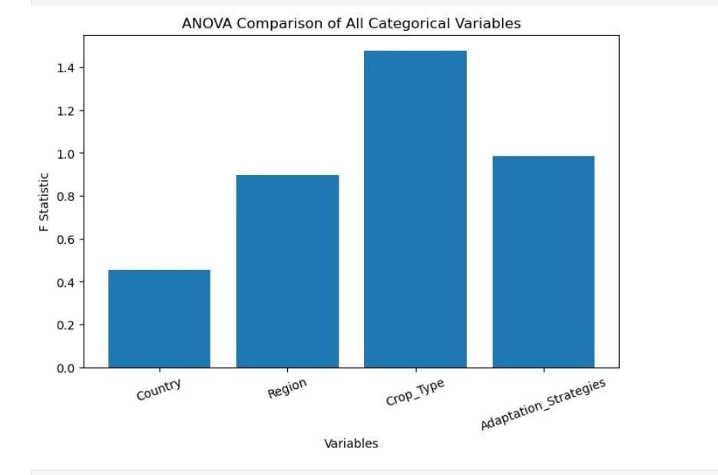 Figure.5.2.3.1. Boxplot Visualisation

Observation
- All groups have comparable median crop yields.
- There is a lot of overlap between the boxplots.
- The p-values exceed 0.05.

Interpretation
Comparing agricultural productivity across many categories is made possible by the boxplot. Wider boxes imply more crop yield variability, whereas groups with higher median values show higher average productivity. A visual representation of how much or how little there are differences between groups is given by the overlap between boxplots.

Conclusion
By graphically depicting the distribution of agricultural yield among various groups, the boxplot enhances the ANOVA results. It validates the statistical findings from the ANOVA analysis and assists in confirming the significance of observed productivity disparities. 5.2.4.

Trend Analysis Visualization
Objective
To identify changes in agricultural productivity over time.

Justification
Long-term trends and temporal patterns are clearly displayed by line plots. Observation
- Over time, crop production varies slightly.
- There isn't a discernible increasing or declining tendency.
- The slope of the trend is almost nil.

Output
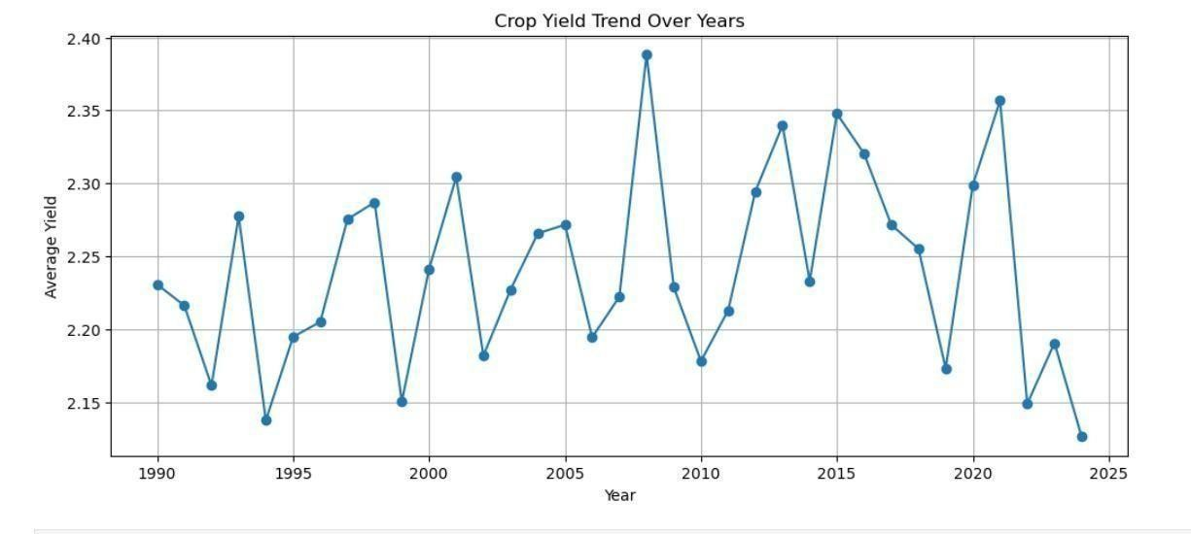
Figure5.2.4.1. Trend Analysis Visualization

Interpretation
- During the course of the trial, crop yield stayed comparatively constant.
- There were slight variations.
- There was no discernible rise or fall.

Conclusion
Within the sample, agricultural productivity showed consistent long-term trends.

5.2.5. Boxplot for Adaptation Strategies
Objective
To compare crop yield distributions among adaptation strategies.

Justification
Boxplots are useful for displaying spread, variability, median values, and possible group differences.

Output
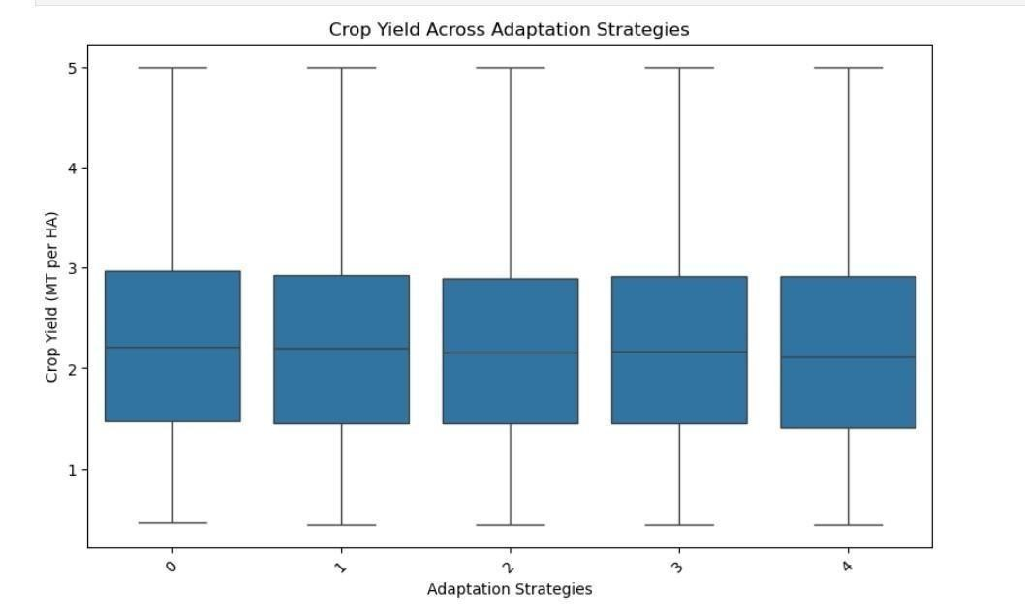
Figure5.2.5.1. Boxplot for Adaptation Strategies

Observation
- The median crop yields of all adaption techniques are comparable.
- There is overlap in the distributions.
- p = 0.381 and H = 4.191.

Interpretation
- Across adaption options, crop yield distributions were comparable.
- There was no approach that demonstrated a significantly higher level of production.

Conclusion
Crop yield variations were not statistically significant as a result of adaptation techniques

5.3 Summary of Data Visualization :
By offering distinct visual depictions of the connections between climate conditions and agricultural productivity, the visualizations successfully complemented the data investigations. The correlation heatmap shows that temperature is the climate variable most closely linked to agricultural yield. The regression coefficient plot indicated that CO2 emissions had a negative impact, while temperature was the most significant positive predictor. The agricultural yield distributions across nations, geographies, crop kinds, and adaptation tactics do not differ statistically significantly, according to the ANOVA boxplots. Trend analysis reveals that there was relatively little variation in agricultural productivity during the study period. Crop yield distributions across various adaptation strategies were similar, according to the Kruskal-Wallis boxplot.

6.EXPLORATORY DATA ANALYSIS

6.1 Introduction

Exploratory data analysis (EDA) is a crucial step in the data analysis process that helps researchers understand the characteristics, quality, and structure of a dataset prior to applying statistical techniques. In order to find patterns, trends, correlations, and likely anomalies, the dataset must be examined using descriptive statistics and graphical visualizations. EDA can help identify outliers, inconsistent data, duplicate records, and missing variables that could jeopardize the accuracy of the analysis. It also provides data on the distribution of numerical and category variables. In this study, EDA was applied to the Crop output Prediction Dataset in order to gain a better understanding of the climate and agricultural factors influencing crop output. Before doing complex statistical analyses, the data was summarized and its quality assessed using a variety of exploratory techniques.
An introduction of the dataset, an assessment of the quality of the data, descriptive statistics, and simple visualizations are all included in the analysis. These procedures contributed to the dataset's completeness, consistency, and potential for additional investigation. EDA also assisted in identifying the variables that were most crucial to achieving the study's objectives. Correlation analysis, multiple linear regression, ANOVA, trend analysis, and the KruskalWallis test were all based on the insights obtained during this phase. Overall, by offering a thorough understanding of the dataset prior to model construction and hypothesis testing, exploratory data analysis improved the validity and reliability of the statistical results.

6.2 Dataset Overview
The dataset overview provides a summary of the data used in this investigation. It describes the origin, characteristics, variables, and structure of the dataset. Understanding the dataset is essential to determining whether it qualifies for statistical analysis and what kind of information is available. The dataset used in this study includes climate, agricultural, and environmental factors that impact crop productivity. It serves as the foundation for all statistical studies utilized in this book, including correlation analysis, multiple linear regression, ANOVA, trend analysis, and the Kruskal-Wallis test.

6.2.1 Dataset Description
The Crop Yield Prediction Dataset, which was acquired via the Kaggle platform, was utilized in this study. It is a publicly accessible dataset created to examine how agricultural, environmental, and climatic factors relate to crop productivity. The dataset includes data on several crop types and adaption techniques from several nations and locations. Important factors including Average Temperature (°C), Total Precipitation (mm), CO2 Emissions (MT),
Crop Yield (MT per HA), Irrigation Access (%), Soil Health Index, Fertilizer Use (kg/ha),
Pesticide Use (kg/ha), Crop Type, Country, Region, and Adaptation Strategy are all included. Crop Yield (MT per HA), which stands for agricultural productivity, is the dataset's aim
variable.
The dataset was selected because it contains information for statistical studies on the impact of climate change on crop productivity.

6.2.2 Dataset Information
Property | Description
Dataset Name | Crop Yield Prediction Dataset
Source | Kaggle
Dataset Link | https://www.kaggle.com/datasets/patelris/crop-yield-prediction-dataset
Property | Description
Dataset  Domain | Agriculture and Climate Change
Data Type | Structured Tabular Dataset
File Format | CSV
Number of  Records | 10,000
Number of  Attributes | 15
Target Variable | Crop Yield (MT per HA)
Numerical  Variables | Average Temperature, Total Precipitation, CO₂ Emissions, Irrigation Access,  Soil Health Index, Fertilizer Use, Pesticide Use, Crop Yield
Categorical  Variables | Country, Region, Crop Type, Adaptation Strategy
Analysis  Techniques  Used | Correlation Analysis, Multiple Linear Regression, ANOVA, Trend Analysis,  Kruskal–Wallis Test
Table 6.2.1: Dataset Information

6.3 Descriptive Statistics
Descriptive statistics provide a numerical description of the data by describing the distribution, variability, and central tendency of the dataset. They help researchers understand the characteristics of numerical variables before conducting complex statistical analyses. Descriptive statistics help interpret the overall behavior of the dataset by condensing large volumes of data into useful numerical values.
Using the Pandas describe() function, descriptive statistics were calculated for every numerical variable in this project. The statistical summary includes metrics such as count, mean, standard deviation, minimum value, maximum value, first quartile (25%), median (50%), and third quartile (75%). These measurements offered insightful information on agriculture productivity and meteorological factors.
Descriptive statistics also helped identify the range and variability of the observations in order to assess whether the dataset was suitable for further statistical analysis.

6.3.1. Statistical Summary
The statistical summary provides a concise numerical description of the dataset. The summary includes the following statistical measures:

Count
Represents the total number of observations available for each numerical variable. In this project: Count = 10,000 indicating that every numerical variable contains complete observations.

Mean
The mean is the arithmetic average of all observations.
It represents the central value around which the data is distributed.
The mean helps understand the average climatic conditions and agricultural productivity recorded in the dataset.

Standard Deviation
Standard deviation measures the spread of observations around the mean.
A high standard deviation indicates greater variability, whereas a low standard deviation indicates more consistent observations.

Minimum Value
The minimum value represents the smallest recorded observation for each numerical variable.
It identifies the lowest climatic or agricultural measurement present in the dataset.

25th Percentile (Q1)
The first quartile indicates that 25% of observations fall below this value.
It represents the lower portion of the data distribution.

Median (50%)
The median represents the middle value of the dataset.
Half of the observations lie below the median, while the remaining half lie above it.
The median is less affected by extreme values than the mean.

75th Percentile (Q3)
The third quartile indicates that 75% of observations fall below this value.
It represents the upper portion of the data distribution.

Maximum Value
The maximum value represents the highest recorded observation for each variable.
It defines the upper limit of the dataset.
6.3.2. Boxplot Analysis

Introduction
A boxplot is a graphical representation that uses five statistical measures—minimum, first quartile (Q1), median, third quartile (Q3), and maximum—to summarize the distribution of numerical data. Additionally, it finds possible outliers that deviate greatly from the bulk of observations. In order to analyze data variability and find extreme observations prior to statistical analysis, boxplots were created for Crop Yield and Average Temperature in this project. Outliers were carefully assessed rather than automatically eliminated because climatic data naturally contains volatility.

Purpose
- To find anomalies.
- To investigate variability.
- To see the distribution of data.
- To evaluate how numerical variables are distributed.

Observation
•Most observations lie within the interquartile range.
•Outside the whiskers, a few extreme values show up.
• The median is located in the middle of the box.

Interpretation
The boxplot shows that although there are occasional outliers, they most likely reflect actual agricultural or meteorological conditions rather than data inaccuracies. These observations were therefore kept for statistical examination.

Conclusion
The boxplot verifies that the dataset is appropriate for statistical analysis and has acceptable variability.
6.3.3. Pair Plot Analysis

Introduction
One visualization method for looking at relationships between several numerical variables at once is a pair plot. It shows the distribution of each variable along the diagonal as well as scatter plots for every pair of variables. Before doing formal statistical studies, pair plots offer a summary of potential correlations, trends, and grouping tendencies. In order to investigate the relationships between Average Temperature, Total Precipitation, CO2 Emissions, and Crop
Yield, pair plots were created.

Purpose
- To investigate correlations between several numerical variables.
- To find potential linkages and patterns.
- To see how data are distributed.
- To facilitate the choice of features.

Observation
- There is a marginally positive correlation between temperature and crop yield.
- There is a little negative correlation between CO2 emissions and crop yield.
- There is very little correlation between rainfall and crop yield.
- The distributions of the majority of variable pairs are dispersed.

Interpretation
An initial visual comprehension of the correlations between climate variables is provided by the pair plot. Detailed statistical findings are saved for the correlation and regression studies in subsequent chapters, even if certain relationships are apparent.
Conclusion
The selection of variables for additional statistical analysis was facilitated by the pair plot, which also aided in dataset exploration.
6.3.4. Correlation Matrix

Introduction
A numerical table that shows the correlation coefficients between numerical variable pairs is called a correlation matrix. It offers a preliminary summary of the relationships between variables without going into great depth. Prior to doing Pearson Correlation Analysis in this research, a correlation matrix was created to investigate the connections between crop yield and climate variables.

Purpose
- To examine relationships among numerical variables.
- To identify variables with positive or negative associations.
- To support feature selection.

Observation
- Average Temperature has the strongest positive correlation with Crop Yield.
- CO₂ Emissions show a weak negative correlation.
- Most variables exhibit weak to moderate relationships.

Interpretation
A thorough statistical analysis and interpretation are provided later in the project under
Objective 1. The correlation matrix offers an initial understanding of variable relationship Conclusion
correlation matrix serves as an exploration tool for exploring potential correlations among the variables.

6.4. Summary of Exploratory Data Analysis (EDA)
This project's Exploratory Data Analysis (EDA) provided a comprehensive understanding of the Crop Yield Prediction Dataset prior to employing sophisticated statistical techniques. The dataset underwent a thorough examination to assess its overall eligibility for analysis as well as its quality and structure. The dataset's summary confirmed that it contained relevant environmental, agricultural, and climate variables required to look into how agricultural productivity is impacted by climate change. All variables were saved using the appropriate data types, and the dataset was complete with no duplicate records or missing values, according to the data quality evaluation. Descriptive statistics offered important insights into the characteristics of the dataset by describing the distribution, central tendency, and variability of the numerical variables. Exploratory visualizations, such boxplots and histograms, assisted in understanding the distribution of significant variables and identifying any outliers prior to statistical analysis. Overall, the EDA confirmed that the dataset was reliable, clean, consistent, and structured for further analysis.

7.MODEL BUILDING/ADVANCED DATA TECHNIQUES

7.1 Introduction

The main analytical stage of this study is Model Building and Advanced Data Analysis Techniques, where statistical techniques are used to examine how climate change affects agricultural productivity. The correlations between climatic, environmental, and agricultural variables were examined using sophisticated statistical approaches after data preprocessing, exploratory data analysis, and data visualization. This phase's main goals were to compare agricultural productivity across various groups, identify important factors impacting crop yield, examine long-term trends, and assess the efficacy of adaptation measures.
The strength and direction of the associations between climate factors and agricultural yield were assessed in this study using Pearson Correlation Analysis. To measure the combined impact of several climate variables on agricultural productivity and determine the most important predictors, multiple linear regression was used. To ascertain whether there were notable variations in crop production among nations, regions, crop varieties, and adaptation tactics, One-Way Analysis of Variance (ANOVA) was used. To look at how agricultural productivity has changed over time and spot long-term trends, trend analysis was done. Lastly, to determine if various adaptation strategies produced statistically significant variations in crop output, the Kruskal–Wallis Test, a non-parametric statistical technique, was employed.
All analyses were carried out using Python libraries, including Pandas, NumPy, SciPy, Scikitlearn, Matplotlib, and Seaborn, within the Jupyter Notebook environment. The outputs generated from these techniques, including statistical measures, graphical visualizations, and hypothesis testing results, were interpreted to achieve the research objectives. Overall, this chapter demonstrates how advanced statistical methods were systematically applied to analyze the dataset and draw meaningful conclusions regarding the impact of climate change on
agricultural productivity.
7.2 Pearson Correlation Analysis (Objective 1)
Objective: To analyze the relationship between climate variables and crop yield.

Justification
Pearson Correlation Analysis is a statistical technique used to measure the strength and direction of the linear relationship between two continuous numerical variables. It was selected for this study because the objective was to identify how climate variables influence agricultural productivity. By calculating the Pearson correlation coefficient, the analysis determines whether variables are positively correlated, negatively correlated, or show little to no relationship. This method also helps identify the most influential climate variable affecting crop yield and provides a foundation for the Multiple Linear Regression analysis performed in the next objective.

Mathematical Formula
The Pearson Correlation Coefficient is calculated as:
𝑟 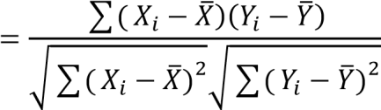
Where:
- 𝑋𝑖= Climate variable
- 𝑌𝑖= Crop Yield
- 𝑋̅= Mean of climate variable
- 𝑌̅= Mean of crop yield
- 𝑟= Pearson correlation coefficient

Methodology
The numerical variables in the Crop Yield Prediction Dataset were first selected for correlation analysis. Pearson correlation coefficients were then computed to measure the relationship between each climate variable and crop yield. The results were presented in the form of a Correlation Matrix and Correlation Heatmap. Additionally, a Scatter Plot was generated to visually examine the relationship between Average Temperature and Crop Yield. These visualizations helped identify both the direction and strength of the relationships before applying regression analysis.
Note: The complete Python implementation used for Pearson Correlation Analysis is provided in Appendix B.

Output 1: Correlation Matrix
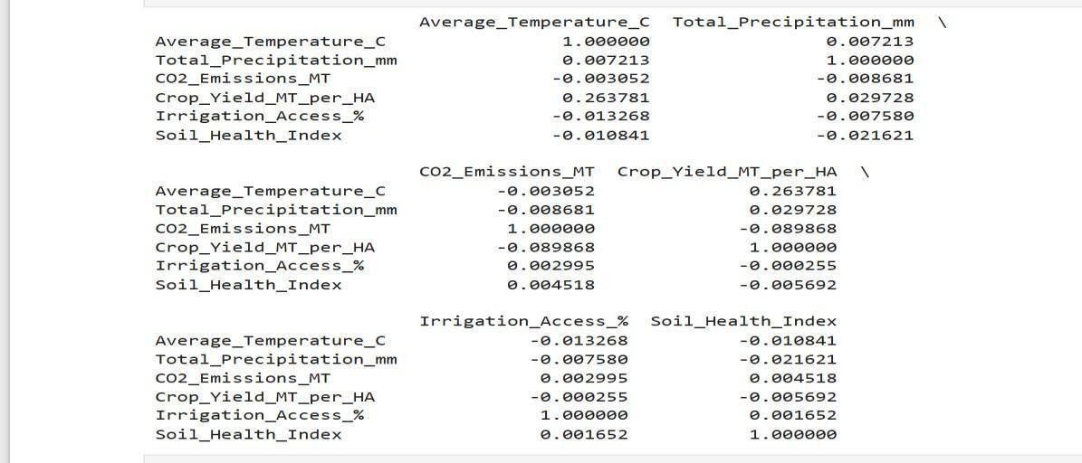
Figure 7.2.1: Correlation Matrix showing Pearson correlation coefficients among climate variables and crop yield.

Output 2: Correlation Heatmap
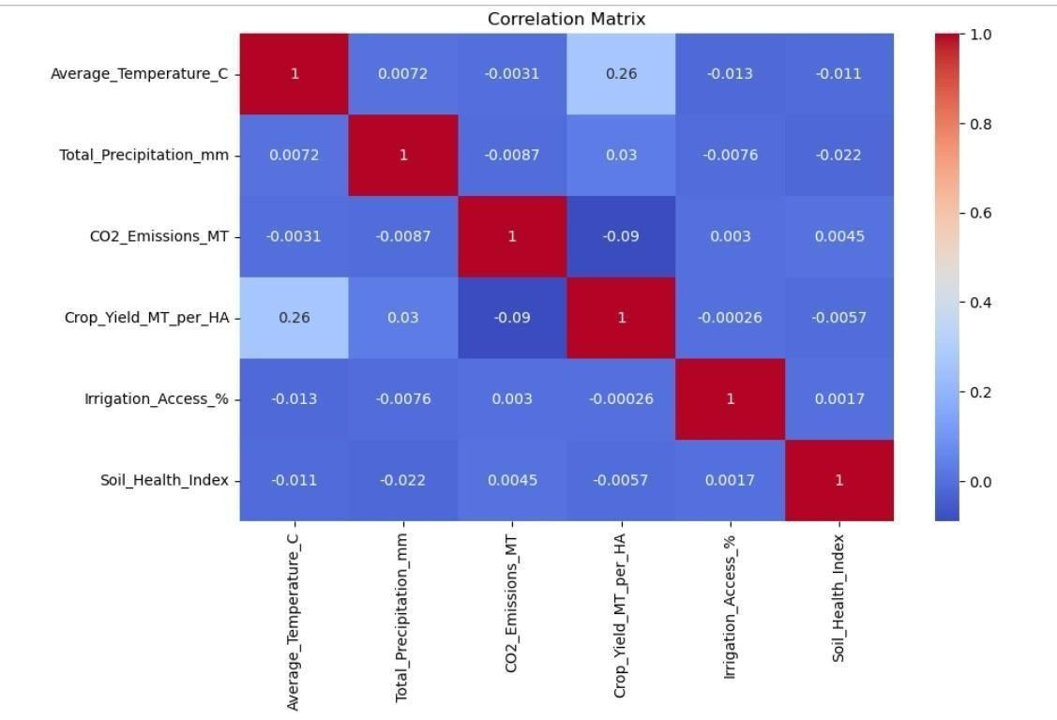
Figure 7.2.2: Correlation Heatmap representing the strength and direction of relationships among numerical variables.

Output 3: Scatter Plot
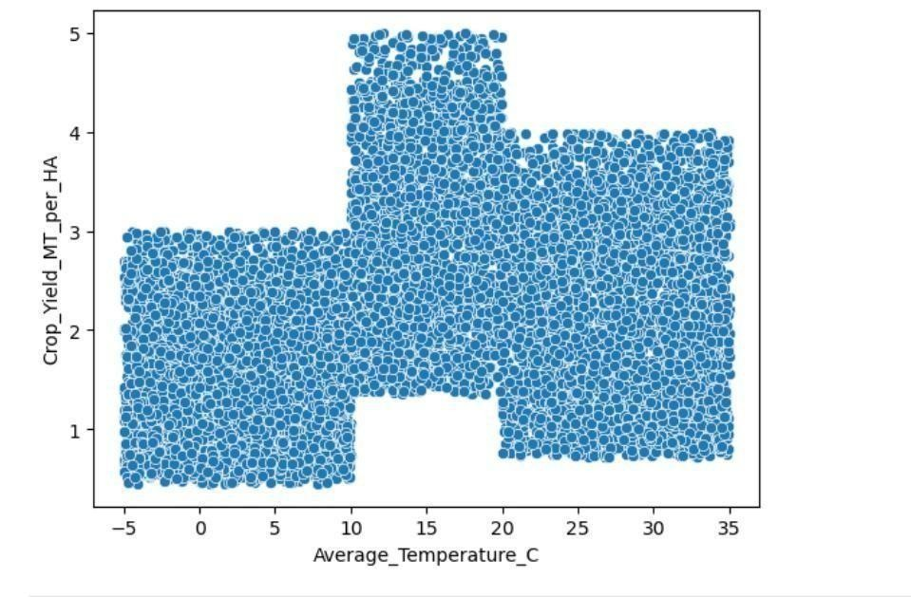
Figure 7.2.3: Scatter Plot showing the relationship between Average Temperature and Crop
Yield.

Output 4 : Descriptive Statistics and Pearson Correlation Summary
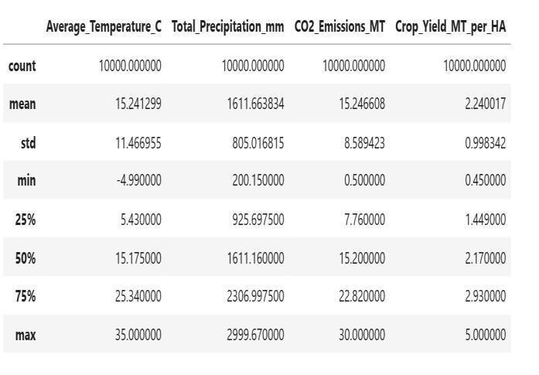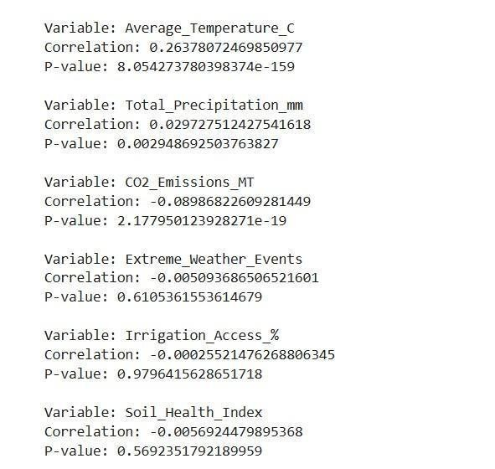
Figure7.2.4:Descriptive Statistics and Pearson Correlation Summary

Observation
The Pearson Correlation Analysis produced the following observations:
- Average Temperature showed the highest positive correlation with Crop Yield.
- The correlation coefficient between Average Temperature and Crop Yield was r =
0.264.
- Total Precipitation exhibited a weak positive relationship with crop yield.
- CO₂ Emissions showed a weak negative correlation with crop yield.
- Irrigation Access and Soil Health Index displayed negligible correlations with crop
yield.
- The scatter plot indicated a slight upward trend, suggesting that crop yield tends to increase slightly with increasing temperature.
- The heatmap confirmed that most climate variables have weak to moderate correlations with agricultural productivity.

Interpretation
The Pearson correlation coefficient measures the strength and direction of a linear relationship between two variables.
The obtained correlation coefficient of r = 0.264 indicates a weak positive linear relationship between Average Temperature and Crop Yield. This means that, within the dataset, an increase in average temperature is associated with a slight increase in crop yield. However, the relatively low correlation value suggests that temperature alone cannot fully explain variations in agricultural productivity.
Similarly, Total Precipitation showed only a weak positive relationship, while CO₂ Emissions exhibited a weak negative relationship with crop yield. Irrigation Access and Soil Health Index demonstrated negligible linear associations. These findings indicate that agricultural productivity is influenced by the combined effects of multiple climatic and environmental factors rather than a single variable.

Result
The Pearson Correlation Analysis identified Average Temperature as the most influential climate variable affecting agricultural productivity. Among all variables considered, it exhibited the highest positive correlation with Crop Yield (r = 0.264). Although this relationship is positive, its strength is relatively weak, indicating that additional climatic, environmental, and agricultural factors also contribute to crop yield variability.

Conclusion
Pearson Correlation Analysis successfully achieved the first research objective by identifying the relationships between climate variables and crop yield. The analysis demonstrated that
Average Temperature has the strongest positive association with agricultural productivity, while CO₂ Emissions have a weak negative influence. The overall results indicate that climate variables collectively affect crop yield, but no single factor is sufficient to explain agricultural productivity independently. These findings provided the statistical basis for applying Multiple Linear Regression in Objective 2 to evaluate the combined influence of multiple climate variables on crop yield.

7.3 Multiple Linear Regression (Objective 2)
Objective: To identify the most significant climate factors affecting agricultural productivity using regression analysis.

Justification
Multiple Linear Regression was selected because crop yield is influenced by multiple climate and agricultural variables simultaneously rather than by a single factor. This statistical technique estimates the combined effect of several independent variables on one dependent variable. It also quantifies the contribution of each predictor and evaluates the overall performance of the regression model using measures such as the Coefficient of Determination (R²), Mean Absolute Error (MAE), and Root Mean Square Error (RMSE).
This method extends the findings of Pearson Correlation Analysis by assessing the joint influence of climate variables on agricultural productivity.

Mathematical Formula
The Multiple Linear Regression model is expressed as:
𝑌 =𝛽0 +𝛽1𝑋1 +𝛽2𝑋2 +𝛽3𝑋3 +𝛽4𝑋4 +𝛽5𝑋5 +𝛽6𝑋6 +𝜀
Where:
- Y = Crop Yield (MT/HA)
- β₀ = Intercept
- β₁...β₆ = Regression coefficients
- X₁ = Average Temperature
- X₂ = Total Precipitation
- X₃ = CO₂ Emissions
- X₄ = Extreme Weather Events
- X₅ = Irrigation Access
- X₆ = Soil Health Index • ε = Random error term

Assumptions of Multiple Linear Regression
The regression analysis was performed under the following assumptions:
- A linear relationship exists between the independent variables and crop yield.
- Observations are independent of one another.
- The residuals are approximately normally distributed.
- The variance of residuals remains constant (homoscedasticity).
- Independent variables do not exhibit severe multicollinearity.
- The regression model includes the major variables influencing crop yield.

Methodology
The selected climate variables were used as independent variables, while Crop Yield served as the dependent variable. The regression model was fitted using the training dataset to estimate the regression coefficients. Model performance was evaluated using the Coefficient of Determination (R²), Mean Absolute Error (MAE), and Root Mean Square Error (RMSE). A regression coefficient graph was generated to visualize the direction and magnitude of each predictor's influence on crop yield.
Note: The complete Python implementation for Multiple Linear Regression is provided in Appendix C.

Output 1

Regression Coefficient Table
Predictor Variable | Regression Coefficient
Average Temperature | 0.023155
Total Precipitation | 0.000041
CO₂ Emissions | -0.009614
Irrigation Access | 0.000035
Soil Health Index | 0.000102
Table 7.3.1: Regression Coefficients.

Output 2: Regression Coefficient Graph
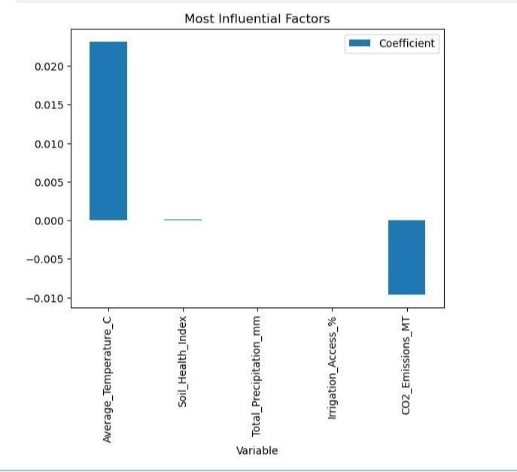
Figure 7.3.2: Regression coefficients showing the direction and strength of each predictor.

Output 3: Model Performance Metrics
Metric | Value
R² Score | 0.0679
MAE | 0.8140948768637695
RMSE | 0.9918756625858567
Table 7.3.3: Multiple Linear Regression performance metrics.

Observation
The Multiple Linear Regression model produced the following observations:
- Average Temperature has the highest positive regression coefficient (0.023155), indicating that it contributes most positively to crop yield.
- CO₂ Emissions have the largest negative coefficient (−0.009614), indicating an inverse relationship with crop yield.
- Total Precipitation, Irrigation Access, and Soil Health Index have positive coefficients but their effects are relatively small.
- The model achieved an R² score of 0.0679, indicating that the selected variables explain approximately 6.79% of the variation in crop yield.
- The RMSE (0.9919) and MAE quantify the model's prediction error.

Interpretation
The regression coefficients quantify the effect of each predictor on crop yield while holding the other variables constant.
- A positive coefficient indicates that an increase in the predictor is associated with an increase in crop yield.
- A negative coefficient indicates that an increase in the predictor is associated with a decrease in crop yield.
Based on your results:
- Average Temperature has the strongest positive influence on crop yield (0.023155).
- CO₂ Emissions have the strongest negative influence (−0.009614).
- The remaining variables have only minor positive effects.
- The R² value of 0.0679 suggests that other factors not included in the model also contribute to agricultural productivity.

Result
Multiple Linear Regression identified Average Temperature as the most influential positive predictor of crop yield and CO₂ Emissions as the strongest negative predictor. The model explained approximately 6.79% of the variation in agricultural productivity, with an RMSE of
0.9919 and an MAE equal to the value obtained from the model output.

Conclusion
Multiple Linear Regression successfully addressed the second research objective by evaluating the combined effects of multiple climate variables on agricultural productivity. The analysis demonstrated that Average Temperature has the greatest positive influence on crop yield, while CO₂ Emissions negatively affect agricultural productivity. Although the model explains only a modest proportion of crop yield variation (R² = 0.0679), it confirms that climate variables collectively contribute to agricultural productivity. The findings also indicate that additional factors beyond those included in the model influence crop yield, suggesting opportunities for future studies to incorporate broader environmental and agricultural variables. 7.4 One-Way ANOVA Analysis (Objective 3)
Objective: To compare agricultural productivity across different regions, crop types,country and Adaptation Strategies using ANOVA.

Justification
One-Way Analysis of Variance (ANOVA) was selected because it is an appropriate statistical technique for comparing the mean crop yield across more than two independent groups. Unlike a t-test, which compares only two groups, ANOVA allows simultaneous comparison of multiple categories while controlling the overall Type I error rate.
In this project, ANOVA was applied to evaluate whether Country, Region, Crop Type, and Adaptation Strategy significantly influence agricultural productivity. In addition to determining statistical significance through the F-test, the Eta Squared (η²) effect size was calculated to measure the magnitude of the differences among groups.

Mathematical Formula
The F-statistic is calculated as:
Mean Square Between Groups (MSB)
𝐹 =
Mean Square Within Groups (MSW)
Where:
- MSB = Mean Square Between Groups
- MSW = Mean Square Within Groups
The Mean Squares are computed as:
𝑆𝑆𝐵
𝑀𝑆𝐵 =
𝑘−1
𝑆𝑆𝑊
𝑀𝑆𝑊 =
𝑁−𝑘
Where:
- SSB = Sum of Squares Between Groups
- SSW = Sum of Squares Within Groups
- k = Number of groups
- N = Total number of observations
Eta Squared (η²)
Where:
- η² = Effect Size
- SSBetween = Sum of Squares Between Groups
- SSTotal = Total Sum of Squares
Eta Squared measures the proportion of total variance in crop yield that is explained by the grouping variable. Hypotheses

Null Hypothesis (H₀)
There is no statistically significant difference in the mean crop yield among the different groups.

Alternative Hypothesis (H₁)
There is a statistically significant difference in the mean crop yield among at least one of the groups.

Decision Rule
- If p-value < 0.05, reject the null hypothesis.
- If p-value ≥ 0.05, fail to reject the null hypothesis.

Assumptions of One-Way ANOVA
The One-Way ANOVA was conducted under the following assumptions:
- Crop Yield is a continuous variable.
- The independent variables are categorical.
- Observations are independent.
- Crop yield values are approximately normally distributed within each group.
- Variances among the groups are approximately equal.

Methodology
The dataset was grouped based on Country, Region, Crop Type, and Adaptation Strategy. Separate One-Way ANOVA tests were performed for each grouping variable. The F-statistic and p-value were calculated to determine statistical significance. In addition, Eta Squared (η²) was computed to evaluate the practical significance (effect size) of each grouping variable. Boxplots were generated to visualize the distribution of crop yield across the different groups, and a bar chart was used to compare the F-statistics.
Note: The complete Python implementation for One-Way ANOVA is provided in Appendix D.

Output 1: ANOVA Bar Chart

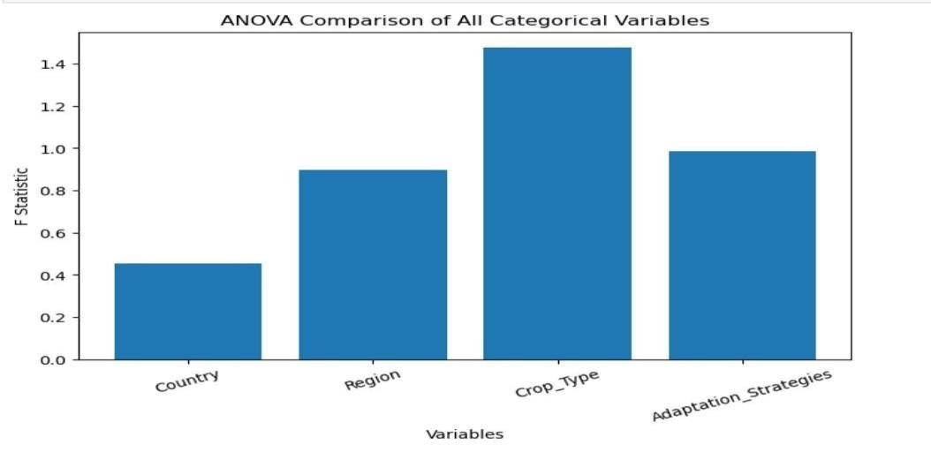
Figure 7.4.1: Comparison of F-statistics across Country, Region, Crop Type, and Adaptation Strategy.

Output 2: Boxplots
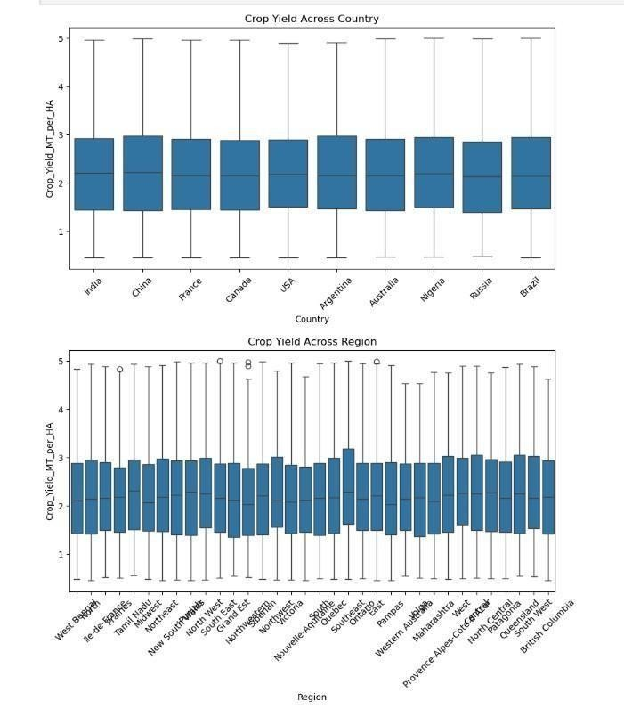
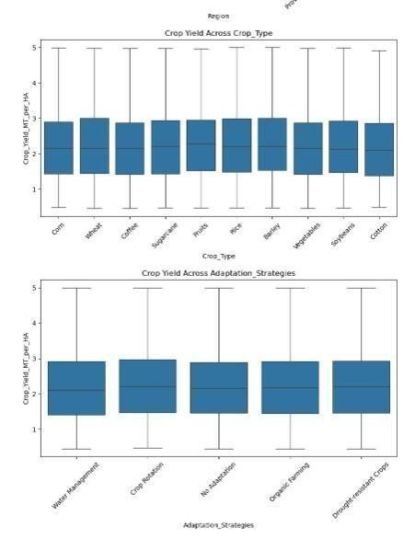
Figure 7.4.2: Distribution of Crop Yield across Countries, Regions, Crop Types, and Adaptation Strategies.

Output 3: ANOVA Results
Variable | F-statistic | p-value | Eta Squared (η²) | Decision
Country | 0.45320278886 | 0.906107813371 | 0.00041 | No significance
Region | 0.89766022111 | 0.635942600484 | 0.00296 | No significance
Crop Type | 1.47743263419 | 0.149802689420 | 0.00133 | No significance
Adaptation Strategy | 0.98515678411 | 0.414153254253 | 0.00039 | No significance
Table 7.4.1: One-Way ANOVA Results.

Observation
The One-Way ANOVA produced the following observations:
- F-statistics and p-values were calculated for all four categorical variables.
- The boxplots showed the distribution of crop yield within each category.
- Eta Squared (η²) values indicated the proportion of crop yield variation explained by each grouping variable.
- Lower η² values indicated that the grouping variables explained only a small proportion of the variability in crop yield.

Interpretation
The F-statistic measures whether the differences among group means are greater than would be expected by random variation. The p-value determines whether these differences are statistically significant.
Eta Squared (η²) measures the effect size, indicating how much of the variation in crop yield is explained by each categorical variable. A larger η² value represents a stronger practical influence of that variable on agricultural productivity, whereas a smaller η² value indicates a weaker influence.
The boxplots complement the statistical results by visually comparing the distributions, medians, and variability of crop yield across the different groups.

Result
The One-Way ANOVA evaluated the influence of Country, Region, Crop Type, and Adaptation Strategy on agricultural productivity. The F-statistics and p-values determined whether the observed differences in mean crop yield were statistically significant, while Eta Squared (η²) quantified the magnitude of these differences. Together, these measures provided both statistical and practical insights into the effects of the categorical variables.

Conclusion
One-Way ANOVA successfully addressed the third research objective by comparing agricultural productivity across multiple categorical groups. The analysis combined the
Fstatistic, p-value, and Eta Squared (η²) to evaluate both statistical significance and effect size. The accompanying boxplots provided visual support for the findings. Overall, the analysis identified the extent to which each grouping variable influenced crop yield and provided a comprehensive understanding of differences in agricultural productivity across the categories included in the study.

7.5 Trend Analysis (Objective 4)
Objective: To analyze trends and patterns in agricultural productivity over time using time series analysis.

Justification
Trend Analysis was selected to examine the long-term behavior of agricultural productivity over time. It helps determine whether crop yield exhibits an increasing, decreasing, or stable pattern under changing climatic conditions. Unlike correlation and regression analyses, which study relationships among variables, Trend Analysis focuses on identifying the overall direction of change in crop yield throughout the study period. This analysis provides insights into the sustainability and consistency of agricultural productivity and supports understanding of longterm climate impacts.

Mathematical Formula
Since you used Pearson Correlation to evaluate the trend, the mathematical formula should be the Pearson Correlation formula, not the slope equation.
Where
- r = Pearson Correlation Coefficient
- X = Year
- Y = Crop Yield
- X̄ = Mean Year
- Ȳ = Mean Crop Yield

Assumptions
- Year is treated as a continuous numerical variable.
- Crop Yield is a continuous numerical variable.
- The relationship between Year and Crop Yield is linear.
- Observations are independent.
- No major measurement errors exist in the dataset.

Methodology
The dataset was grouped according to Year, and the average crop yield for each year was calculated. A line graph was generated to visualize changes in agricultural productivity over time. Pearson Correlation Analysis was then performed to measure the relationship between Year and Crop Yield. Finally, a regression trend line was plotted using Seaborn's regplot() function to visualize the overall direction of the trend.
Note: The complete Python implementation for Trend Analysis is provided in Appendix E. Output 1
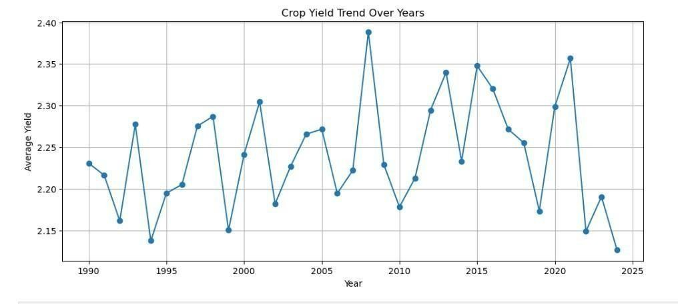
Figure 7.5.1 Crop Yield Trend Over Years

Output 2
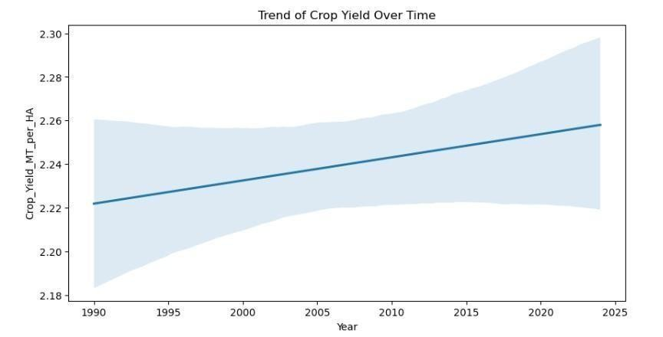
Figure 7.5.2 Trend of Crop Yield Over Time

Output 3
Trend Analysis Results
Measure | Value
Pearson Correlation (r) | 0.010734311989200293
p-value | 0.28312400691012374
Table 7.5.1 Trend Analysis Results

Observation
- The trend graph illustrates the variation in average crop yield across different years.
- Minor fluctuations in crop yield are observed throughout the study period.
- The regression line indicates the overall direction of the trend.
- The Pearson Correlation coefficient measures the strength and direction of the relationship between Year and Crop Yield.
- The p-value indicates whether the observed trend is statistically significant.

Interpretation
The Trend Analysis indicates the overall pattern of agricultural productivity over time. The correlation coefficient describes whether crop yield tends to increase or decrease as the years progress, while the p-value determines whether this relationship is statistically significant. Based on the obtained results, the observed trend can be interpreted as either significant or nonsignificant depending on the p-value.

Result
The Trend Analysis provided an overview of the changes in agricultural productivity over time. The graphical visualization, together with the Pearson Correlation coefficient and p-value, was used to assess the direction and statistical significance of the observed trend.

Conclusion
Trend Analysis successfully achieved the fourth research objective by examining changes in agricultural productivity over time. The analysis combined graphical visualization with Pearson Correlation Analysis to evaluate the relationship between Year and Crop Yield. The results provide insight into the long-term behavior of agricultural productivity and support the overall assessment of climate change impacts on crop yield.

7.6 Kruskal–Wallis Test (Objective 5)
Objective: To evaluate whether adaptation strategies significantly influence agricultural productivity under changing climatic conditions using the Kruskal–Wallis Test.

Justification
The Kruskal–Wallis Test was selected because it is a non-parametric statistical test used to compare three or more independent groups when the assumptions of One-Way ANOVA, particularly the assumption of normality, may not be satisfied. It evaluates whether the distributions of crop yield differ significantly across the various adaptation strategies.

Mathematical Formula
Where:
- H = Kruskal–Wallis statistic
- N = Total number of observations
- k = Number of groups
- Rᵢ = Sum of ranks for group i
- nᵢ = Number of observations in group i
Hypotheses

Null Hypothesis (H₀)
There is no statistically significant difference in crop yield among the different adaptation strategies.

Alternative Hypothesis (H₁)
There is a statistically significant difference in crop yield among at least one of the adaptation strategies.

Decision Rule
- If p-value < 0.05, reject the null hypothesis.
- If p-value ≥ 0.05, fail to reject the null hypothesis.

Assumptions
- Observations are independent.
- Crop Yield is a continuous variable.
- Adaptation Strategy consists of independent groups.
- The data do not need to follow a normal distribution.
- The observations are randomly sampled.

Methodology
The dataset was grouped according to the different adaptation strategies. The Kruskal–Wallis Test was applied to compare crop yield distributions across these groups. The H statistic and pvalue were calculated using the SciPy library. A boxplot was also generated to visually compare the distribution of crop yield among the different adaptation strategies.
Note: The complete Python implementation is provided in Appendix F.

Output 1:Boxplot of Adaptation Strategies
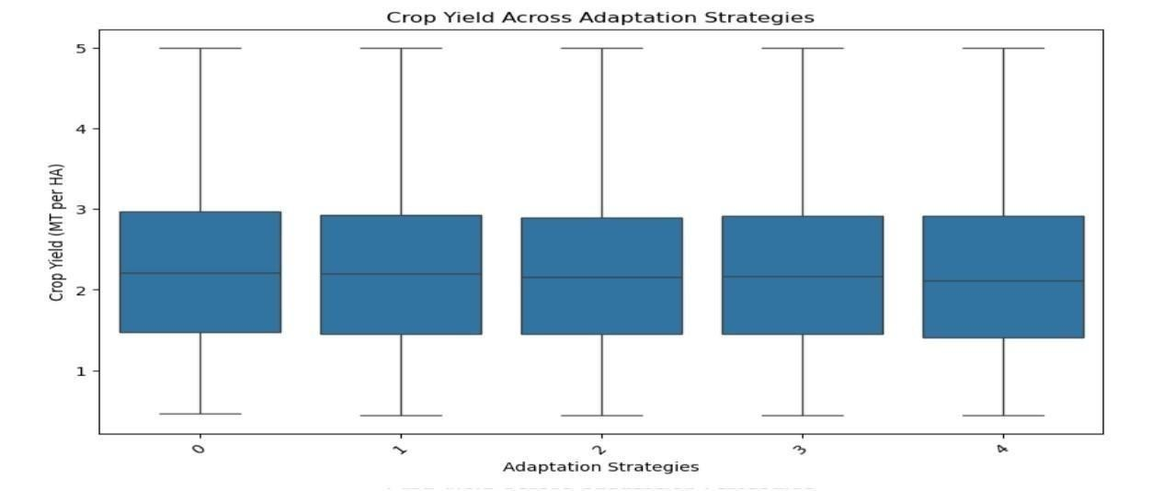
Figure 7.6.1: Crop Yield Distribution across Adaptation Strategies.
Output 2

Kruskal–Wallis Test Results
Measure | Value
H Statistic | 4.191
p-value | 0.381
Significance Level (α) | 0.05
Decision | Fail to Reject H₀
Table 7.6.1: Kruskal–Wallis Test Results.

Observation
- The calculated H statistic is 4.191.
- The p-value is 0.381.
- Since 0.381 > 0.05, the null hypothesis is not rejected.
- The boxplot shows considerable overlap among the crop yield distributions for different adaptation strategies.
- The median crop yield values are similar across the groups.

Interpretation
The Kruskal–Wallis Test compares the ranked distributions of crop yield across the different adaptation strategies. The obtained H statistic of 4.191 indicates the amount of variation among the ranked groups. However, the p-value of 0.381 is greater than the significance level of 0.05, indicating that the observed differences are not statistically significant. The boxplot supports this result by showing similar medians and overlapping interquartile ranges among the adaptation strategy groups.

Result
The Kruskal–Wallis Test indicates that there is no statistically significant difference in agricultural productivity among the different adaptation strategies. Therefore, the observed variation in crop yield is likely due to natural variability within the dataset rather than differences between adaptation strategies.

Conclusion
The Kruskal–Wallis Test successfully addressed the fifth research objective by comparing agricultural productivity across different adaptation strategies. The analysis showed that the differences in crop yield were not statistically significant, as indicated by the H statistic of
4.191 and p-value of 0.381. The boxplot further confirmed that crop yield distributions were similar across the adaptation strategy groups. Based on these findings, it can be concluded that the adaptation strategies included in this dataset did not significantly influence agricultural productivity.

7.7 Summary
The advanced statistical methods used to examine how climate change affects agricultural productivity were described in this chapter. Pearson Correlation Analysis and Multiple Linear Regression identified Average Temperature as the most relevant factor determining crop yield, while the regression model achieved a R² value of 0.0679. Eta Squared (η²) was used in a OneWay ANOVA to assess agricultural productivity among nations, regions, crop kinds, and adaptation tactics. The Kruskal–Wallis Test (H = 4.191, p = 0.381) revealed no statistically significant differences across adaption strategies, and trend analysis revealed comparatively steady crop output over time.

8. CONCLUSIONS & FUTURE SCOPE

8.1 Conclusion
This study used the Climate Change Impact on Agriculture 2024 dataset to examine the effects of specific climate factors on agricultural productivity. Ten thousand records and fifteen attributes that included climatic, agricultural, geographical, adaptive, and economic aspects were included in the collection. To guarantee data quality and dependability, the dataset was first preprocessed using data inspection, missing value analysis, duplication verification, feature selection, and exploratory data analysis. Five statistical methods were used to accomplish the study's goals after the dataset was prepared. The associations between climate variables and agricultural yield were investigated using Pearson Correlation Analysis. According to the findings, CO2 emissions had a slight negative correlation with crop output, but average temperature had the largest positive correlation with agricultural productivity.
The combined impact of climate variables on agricultural productivity was then assessed using multiple linear regression. With an R2 score of roughly 0.0679, the regression model found Average Temperature to be the most significant positive predictor, meaning that the chosen variables accounted for almost 6.79% of the variation in crop output. This implies that production may also be influenced by other environmental, agricultural, and management factors. To compare crop yields across various nations, geographies, crop kinds, and adaptation tactics, one-way ANOVA was used. The computed Eta Squared (η²) values revealed only modest effect sizes, and the analysis revealed that the observed differences between these groups were not statistically significant. To look at how agricultural productivity has changed over time, trend analysis was done. The trend graphs indicated comparatively constant agricultural productivity within the examined dataset, with only slight variations in crop yield.
Lastly, the impact of various adaptation techniques on crop productivity was assessed using the
Kruskal–Wallis Test. There was no statistically significant difference in crop output between the adaptation strategy groups, according to the test's H statistic of 4.191 and p-value of 0.381. Overall, the statistical analyses showed that the chosen climate factors have varied degrees of impact on agricultural productivity, with average temperature emerging as the most significant determinant.
A thorough statistical framework for evaluating climate–agriculture links was produced by combining Pearson Correlation Analysis, Multiple Linear Regression, One-Way ANOVA, Trend Analysis, and the Kruskal–Wallis Test. All five of the study's goals were effectively met, and it offers significant statistical data that can help with future research on climate change and agricultural planning.

8.2 Future Scope
Even if the study's goals were successfully met, there are still a number of chances to expand and enhance the research in the future. To increase the accuracy and generalizability of the findings, future research may make use of bigger and more varied datasets that cover more nations, climate zones, and longer observation times. To offer a more thorough understanding of the factors impacting agricultural productivity, additional climate-related variables such humidity, wind speed, soil moisture, solar radiation, drought indices, and evapotranspiration can be included. Similarly, to increase the statistical models' explanatory power, agricultural variables including fertilizer use, irrigation techniques, insect and disease incidence, crop management strategies, and soil properties can be incorporated.
Future studies may evaluate different crop varieties and regional agricultural systems to better understand location-specific climate impacts. Additional statistical approaches like as Principal Component Analysis (PCA), Factor Analysis, Time Series Analysis, or Structural Equation Modeling may be utilized to provide deeper insights into the interactions among climatic and agricultural factors. The regression analysis can further be extended by integrating additional predictor variables to improve model performance and raise the amount of variation explained in crop output. Future studies may compare the performance of statistical models with machine learning technologies to assess whether predicted accuracy may be improved. The created analytical methodology can also be used to diverse agricultural datasets, crop types, and environmental circumstances to validate the findings.
Additionally, the findings of this study can help farmers, agricultural researchers, and policymakers create evidence-based plans for managing agriculture sustainably in the face of climate change. All things considered, the statistical framework created in this study can be expanded upon in subsequent research to enhance agricultural productivity analysis, bolster planning for climate adaption, and promote long-term sustainable agricultural development.

9.APPENDIX
9.1. Program code for Implementation
Code for Preprocessing :

import pandas as pd

df = pd.read_csv("climate_change_impact_on_agriculture_2024.csv")
print(df.head())

print(df.shape)
print(df.columns)
df.info()

print(df.isnull().sum())

print(df.duplicated().sum())
df.drop_duplicates(inplace=True)

print(df.dtypes)

from sklearn.preprocessing import LabelEncoder

le = LabelEncoder()

categorical_cols = [
'Country',
'Region',
'Crop_Type',
'Adaptation_Strategies'
]

for col in categorical_cols:
df[col] = le.fit_transform(df[col])

import seaborn as sns import
matplotlib.pyplot as plt
numerical_cols= df.select_dtypes( include=['int64','float64']).columns

for col in numerical_cols: plt.figure(figsize=(5,2)) sns.boxplot(x=df[col]) plt.title(col) plt.show() for col in numerical_cols:

Q1 = df[col].quantile(0.25)
Q3 = df[col].quantile(0.75)

IQR = Q3 - Q1

lower = Q1 - 1.5*IQR upper = Q3 + 1.5*IQR

df = df[
(df[col] >= lower) &
(df[col] <= upper)
]

print("Before:", df.shape) print("After:", df.shape)
from sklearn.preprocessing import StandardScaler

scaler = StandardScaler()

numerical_cols = [
'Average_Temperature_C',
'Total_Precipitation_mm',
'CO2_Emissions_MT',
'Extreme_Weather_Events',
'Irrigation_Access_%',
'Pesticide_Use_KG_per_HA',
'Fertilizer_Use_KG_per_HA', 'Soil_Health_Index',
'Economic_Impact_Million_USD'
]

df[numerical_cols] = scaler.fit_transform( df[numerical_cols] )
print(df.shape)

print(df.head())

print(df.describe())

Code for Objective 1:

import pandas as pd import seaborn as sns import matplotlib.pyplot as plt

df = pd.read_csv("climate_change_impact_on_agriculture_2024.csv")
print(df.head())

num_cols = [
'Average_Temperature_C',
'Total_Precipitation_mm',
'CO2_Emissions_MT',
'Crop_Yield_MT_per_HA',
'Irrigation_Access_%',
'Soil_Health_Index'
]

corr_matrix = df[num_cols].corr()

print(corr_matrix)

plt.figure(figsize=(10,6)) sns.heatmap(corr_matrix,
annot=True, cmap='coolwarm') plt.title("Correlation Matrix")
plt.show()

sns.scatterplot(
x='Average_Temperature_C', y='Crop_Yield_MT_per_HA',
data=df
)
plt.show()

df[['Average_Temperature_C',
'Total_Precipitation_mm', 'CO2_Emissions_MT',
'Crop_Yield_MT_per_HA']].describe() from scipy.stats import pearsonr

variables = [
'Average_Temperature_C',
'Total_Precipitation_mm',
'CO2_Emissions_MT',
'Extreme_Weather_Events',
'Irrigation_Access_%',
'Soil_Health_Index'
]

for var in variables:
corr, p = pearsonr(df[var], df['Crop_Yield_MT_per_HA'])

print(f"\nVariable: {var}") print("Correlation:", corr)
print("P-value:",p)

Code for Objective 2:

from sklearn.model_selection import train_test_split
from sklearn.linear_model import LinearRegression

X = df[['Average_Temperature_C',
'Total_Precipitation_mm',
'CO2_Emissions_MT',
'Irrigation_Access_%',
'Soil_Health_Index']]

y = df['Crop_Yield_MT_per_HA']

X_train, X_test, y_train, y_test = train_test_split( X,y,test_size=0.2,random_state=42)

model = LinearRegression()

model.fit(X_train,y_train)

coefficients = pd.DataFrame({
'Variable':X.columns,
'Coefficient':model.coef_
})

print(coefficients)

from sklearn.metrics import r2_score

pred = model.predict(X_test)

print("R2 Score:", r2_score(y_test, pred))

from sklearn.metrics import mean_squared_error import numpy as np

rmse=np.sqrt(mean_squared_error(y_test,pred)) print("RMSE:",rmse)

from sklearn.metrics import mean_absolute_error

print("MAE:", mean_absolute_error(y_test, pred))

coefficients.sort_values( by='Coefficient',
ascending=False ).plot( x='Variable', y='Coefficient', kind='bar'
)

plt.title("Most Influential Factors")
plt.show()

import matplotlib.pyplot as plt

coefficients.plot( x='Variable',
y='Coefficient', kind='bar', legend=False
)

plt.title("Impact of Factors on Crop Yield") plt.xlabel("Variables") plt.ylabel("Regression Coefficient") plt.xticks(rotation=45)
plt.show()

Code for Objective 3:

from scipy.stats import f_oneway

group_variables = [
'Country',
'Region',
'Crop_Type',
'Adaptation_Strategies'
]

for var in group_variables:

groups = [ group['Crop_Yield_MT_per_HA'].values for name, group in df.groupby(var)
]

f_stat, p_value = f_oneway(*groups)
print("\n---------------------------")
print("Variable:", var)
print("F Statistic:",f_stat)
print("P Value:", p_value)

if p_value < 0.05:
print("Significant difference exists")
else:
print("No significant difference")

import matplotlib.pyplot as plt

plt.figure(figsize=(8,5))

plt.bar( anova_results['Variable'],
anova_results['F_Statistic']
)

plt.title('ANOVA Comparison of All Categorical Variables') plt.xlabel('Variables')
plt.ylabel('F Statistic')

plt.xticks(rotation=20)
plt.show()

from scipy.stats import f_oneway

for var in categorical_vars:

grand_mean = df['Crop_Yield_MT_per_HA'].mean()

ss_between = sum( len(group) *
(group['Crop_Yield_MT_per_HA'].mean() - grand_mean)**2
for name, group in df.groupby(var)
)

ss_total = sum(
(df['Crop_Yield_MT_per_HA'] - grand_mean)**2
)

eta_squared = ss_between / ss_total

print(f"{var} : Eta Squared = {eta_squared:.5f}")

import seaborn as sns import matplotlib.pyplot as plt

categorical_vars = [
'Country',
'Region',
'Crop_Type',
'Adaptation_Strategies'
]

for var in categorical_vars:

plt.figure(figsize=(10,5))

sns.boxplot( x=var,
y='Crop_Yield_MT_per_HA', data=df
)

plt.title(f'Crop Yield Across {var}')
plt.xticks(rotation=45)

plt.show()

Code for Objective 4:

yield_trend=df.groupby('Year')[ 'Crop_Yield_MT_per_HA'].mean()

plt.figure(figsize=(12,5))
yield_trend.plot(marker='o')

plt.title("Crop Yield Trend Over Years") plt.xlabel("Year") plt.ylabel("Average Yield") plt.grid(True)

plt.show()

from scipy.stats import pearsonr
corr, p = pearsonr(df['Year'], df['Crop_Yield_MT_per_HA'])

print("Correlation:", corr)
print("P-value:", p)

import seaborn as sns import matplotlib.pyplot as plt

plt.figure(figsize=(10,5))

sns.regplot( x='Year',
y='Crop_Yield_MT_per_HA',
data=df, scatter=False
)

plt.title('Trend of Crop Yield Over Time')
plt.show()

Code for Objective 5:
from scipy.stats import kruskal

# Create groups based on adaptation strategies groups = [ group['Crop_Yield_MT_per_HA'].values for name, group in df.groupby('Adaptation_Strategies')
]

# Kruskal-Wallis Test stat, p_value = kruskal(*groups)

print("Kruskal-Wallis Statistic:", stat)
print("P-value:", p_value)

if p_value < 0.05:
print("Significant difference exists among adaptation strategies") else:
print("No significant difference among adaptation strategies")

import seaborn as sns import matplotlib.pyplot as plt

plt.figure(figsize=(10,6))

sns.boxplot(x='Adaptation_Strategies', y='Crop_Yield_MT_per_HA',
data=df
)

plt.title('Crop Yield Across Adaptation Strategies')
plt.xlabel('Adaptation Strategies')
plt.ylabel('Crop Yield (MT per HA)')
plt.xticks(rotation=45)

plt.show()

10. BIBLIOGRAPHY
1.Zhao, C., Liu, B., Piao, S., Wang, X., Lobell, D. B., Huang, Y., & Asseng, S. (2023). Climate change impact on crop yield. Scientific Reports, 13, 30813.
2.Kumar, S. (2025). Impact of weather variability on crop yields. MPRA Paper, 125806.
3.Hu, X., Zhang, Y., & Wang, L. (2024). Crop yield response to climate variability.
4.Li, Q., Chen, H., & Zhang, T. (2026). Impact of abnormal temperature on crop yield. arXiv Preprint.
5.Ray, D. K., Gerber, J. S., MacDonald, G. K., & West, P. C. (2021). Climate variability explains crop yield variability at the global scale.
6.Iizumi, T., & Ramankutty, N. (2022). Global crop yield sensitivity to climate change.
7. Lobell, D. B., Schlenker, W., & Costa-Roberts, J. (2011). Climate Trends and Global Crop Production Since 1980. Science, 333(6042), 616–620.
8.Wheeler, T., & von Braun, J. (2013). Climate Change Impacts on Global Food Security. Science, 341(6145), 508–513.
9.Rosenzweig, C., Elliott, J., Deryng, D., et al. (2014). Assessing agricultural risks of climate change in the 21st century. Proceedings of the National Academy of Sciences, 111(9), 3268– 3273.
10.Ortiz-Bobea, A., Ault, T. R., Carrillo, C. M., Chambers, R. G., & Lobell, D. B. (2021).
Anthropogenic climate change has slowed global agricultural productivity growth. Nature Climate Change.
11.Jägermeyr, J., Müller, C., Ruane, A. C., et al. (2021). Climate impacts on global agriculture emerge earlier in new generation of climate and crop models. Nature Food.
12.Ainsworth, E. A., & Long, S. P. (2021). 30 years of Free-Air CO₂ Enrichment (FACE): What have we learned about future crop productivity? Global Change Biology.
13.Osman, M. A. A., et al. (2021). Climate Variability and Change Affect Crops Yield under Rainfed Conditions. Agronomy, 11(9), 1680.
14.Hu, T., Zhang, X., Khanal, S., Wilson, R., Leng, G., & Toman, E. M. (2024). Climate change impacts on crop yields: A review of empirical findings, statistical crop models, and machine learning methods. Environmental Modelling & Software.
15.Kelbore, Z. G. (2012). An Analysis of the Impacts of Climate Change on Crop Production. MPRA Paper.
16.Abebaw, S. E. (2025). A Global Review of the Impacts of Climate Change and Agricultural Productivity.
17.Juma, G. S. (2021). Prediction of Crop Yields under a Changing Climate. In Agrometeorology.
18.Aragón, F. M., Oteiza, F., & Rud, J. P. (2019). Climate Change and Agriculture: Subsistence Farmers' Response to Extreme Heat.
19.Gupta, I., Ayalasomayajula, S., Kataria, A., et al. (2023). Innovations in Agricultural Forecasting: A Multivariate Regression Study on Global Crop Yield Prediction.
20.Yavrum, C., Selcuk-Kestel, A. S., & Garrido, J. (2025). Comparative Analysis of WeatherBased Indexes for Crop Yield Prediction.
21.IPCC. (2021). Climate Change 2021: The Physical Science Basis. Cambridge University
Press.
22.FAO. (2023). The Impact of Disasters on Agriculture and Food Security. Food and
Agriculture Organization of the United Nations.
23.Lal, R. (2004). Soil Carbon Sequestration Impacts on Global Climate Change and Food Security. Science.
24.Dell, M., Jones, B. F., & Olken, B. A. (2014). What Do We Learn from the Weather? The New Climate–Economy Literature. Journal of Economic Literature, 52(3), 740–798.
25.Schlenker, W., & Roberts, M. J. (2009). Nonlinear Temperature Effects Indicate Severe Damages to U.S. Crop Yields under Climate Change. Proceedings of the National Academy of Sciences.
26.Lobell, D. B., Burke, M. B., Tebaldi, C., et al. (2008). Prioritizing Climate Change Adaptation Needs for Food Security in 2030. Science.
27.Challinor, A. J., Watson, J., Lobell, D. B., et al. (2014). A Meta-analysis of Crop Yield under Climate Change and Adaptation. Nature Climate Change.
28.Asseng, S., Ewert, F., Rosenzweig, C., et al. (2015). Rising Temperatures Reduce Global Wheat Production. Nature Climate Change.
29.Lobell, D. B., & Gourdji, S. M. (2012). The Influence of Climate Change on Global Crop Productivity. Plant Physiology.
30.Porter, J. R., Xie, L., Challinor, A. J., et al. (2014). Food Security and Food Production Systems. In IPCC Fifth Assessment Report.

11.PLAGIARISM REPORT



